Line List Application

**User Manual**

|  |
| --- |
| December 15, 2023 |
| Asset Data Management |

Revision history

|  |  |  |  |
| --- | --- | --- | --- |
| **Revision** | **Author** | **Date revised** | **Comments** |
| Original | P. Fabrizi | May 29, 2012 | Initial version |
|  | P. Fabrizi | Sep 12, 2012 | Updated screen prints |
|  | P. Fabrizi | Sep 26, 2012 | Included feedback from Conrad Ginter |
|  | P. Fabrizi | Feb 25, 2013 | Updated screen prints |
| 2 | F. Baessa/ S. Brar | April 5, 2017 | Updated document and added line list content from TR-50 Section 6 |
| 3 | R. Fan / J. Rathje | April 25, 2022 | Updated Sections 6.7 - 6.9 |
| 4 | R. Fan / J. Rathje | June 6, 2022 | Various section updates to support retirement of Microsoft Silverlight |
| 5 | R. Fan / J. Rathje | July 15, 2022 | Updated screen prints & Section 6.12.12 |
| 6 | R. Fan / J. Rathje | December 15, 2023 | Updated Appendix 1 - Insulation Thickness |

Table of contents

1 About this Guide 1

2 Introduction 1

3 Accessing the Application 2

3.1 User Roles 2

3.2 Security Matrix 3

3.3 Security Trimming 5

4 Navigating the Interface 6

4.1 Navigation Tabs 6

4.2 Sorting and Filtering Results 7

5 Project 9

5.1 Project Collection 9

5.2 Project Export 9

5.3 Project Line Lists 10

5.4 Project Details 11

5.5 Add an Project 12

5.6 Update a Project 13

5.7 Delete a Project 13

5.8 Project Turnover 14

5.9 Insulation Table Defaults 15

5.9.1 Insulation Table Default Collection 15

5.9.2 Insulation Table Default Details 16

5.9.3 View an Insulation Table Default 17

5.9.4 Edit an Insulation Table Default 18

5.10 Project Roles 21

5.10.1 Project Role Collection 22

5.10.2 Add a Project Role 23

5.10.3 Update a Project Role 24

5.10.4 Delete a Project Role 25

6 Line List 26

6.1 Line List Search 26

6.2 Export Line Lists 27

6.3 Line List Details 28

6.4 Add a Line List 29

6.5 Update a Line List 30

6.6 Change Line List Status 31

6.7 Print for Review 32

6.8 Print and Issue 33

6.9 Print for Reference 34

6.10 Up Rev a Line List 36

6.11 Discard a Draft 36

6.12 Lines on a Line List 37

6.12.1 View Lines 37

6.12.2 Reserve Lines 39

6.12.3 Include Existing Lines 40

6.12.4 Include Reference Lines 41

6.12.5 Check Out Lines 43

6.12.6 Move a Line 44

6.12.7 Copy Line Data 45

6.12.8 Create a Child Line 46

6.12.9 Update a Line 47

6.12.10 Discard a Line 49

6.12.11 Delete a Line 50

6.12.12 Grid Export and Grid Import 51

6.12.13 Concurrent Engineering 54

7 Line Database Search 56

7.1 Search for Lines 56

7.2 Export Lines 57

7.3 Navigate to Line List 57

7.4 Line Details 58

8 Line List Content and Format 60

8.1 Acceptable Line List Field Attributes 60

8.2 Alternate Operating Mode 60

8.3 Specification 61

8.4 Parent/Child Lines 61

8.5 Area Identifier 62

8.6 Location Identifier 62

8.7 Commodity Code 62

8.8 Pipe Specification (Class/Service/Material) 63

8.9 Size NPS 63

8.10 Line Number 63

8.11 Insulation Thickness 63

8.12 Insulation Type 63

8.13 Tracing Design Type 63

8.14 Tracing Hold Temperature 63

8.15 Number of Tracers 63

8.16 Insulation Material 63

8.17 Pipe Segment Format to Define Insulation 63

8.18 Line Routing From/To 64

8.19 Originating P&ID 64

8.20 Schedule/Wall Thickness 65

8.21 Fluid Phase (V/L/M) 65

8.22 Operating Pressure (kPag) 65

8.23 Operating Temperature (°C) 65

8.24 Design Pressure (kPag) 65

8.25 Design Temperature Max (°C) 65

8.26 Design Temperature Min (°C) 65

8.27 Test Pressure (kPag) 66

8.28 Test Medium 66

8.29 Jacketed Lines 66

8.30 EXP Temperature (°C) 66

8.31 Upset Pressure/Temperature (kPag/°C) 66

8.32 MDMT 66

8.33 Corrosion Allowance 67

8.34 X-RAY 67

8.35 NDE CAT 67

8.36 PWHT 67

8.37 Analysis 67

8.38 Painting System 67

8.39 Internal Coating/Liner Specification 68

8.40 Code 68

8.41 ABSA Registration 68

8.42 Pressure Protection PSV/OPPSD 68

8.43 As-Built Status 68

8.44 Notes 68

8.45 Line Revision Number 68

8.46 CSA Pipelines 68

Appendix 1: Acceptable LDT Values for Line List Application i

Appendix 2: Notes Drawing Page (TR, FC, and CL Specs) ix

1. About this Guide

This document is intended for Cenovus staff and Engineering & Procurement Companies (EP’s) who use the Line List Application for the creation of Line Lists / Line Designation Tables, or for searching and viewing Lines. Read through the sections in this guide to learn how to:

* Access the Line List Application
* Create new Projects
  + Assign security roles to EP Users
  + Turnover a Project to Cenovus Field
* Create new Line Lists
  + Reserve Lines
  + Up-Rev and Issue Line Lists
* Search for existing Lines
  + Export to Excel
* Create and view Line Designation Table reports

1. Introduction

**Line List Application** is a Cenovus designed web application that assists in the organization of Line Lists and Lines for Cenovus facilities. The Line List Application provides valuable information that needs to be shared with Cenovus staff, EP’s, and construction teams.

Line Lists are created by various Engineering and Procurement Companies (EP’s) for FCCL projects. Line Lists provide a complete listing of all the Lines created or modified as part of a capital construction, Management of Change (MOC) or Project Initiation Memorandum (PIM) project. Each Line is assigned a unique number. Engineering parameters for each Line are generated and captured in the Line List to enable specification of pipe materials, insulation and tracing, design and operating conditions, and testing requirements for the Line.

In the past, EP’s used a Microsoft Excel template to issue Line Lists. Currently, all Line Lists are issued using the Line List Application. Printed Line Lists from the application are then submitted to Cenovus/EP Document Control when Issued For Construction (IFC).

Legacy Foster Creek lines are not included on the Line List Application. They exist on a read-only [Old Pilot Plant Masterlist](https://cpw.cenovus.com/specifications/FC%20Spec%20Line%20Lists/Old%20Pilot%20Plant%20Masterlist%20Jan%2019%202015.xlsx) spreadsheet which can be found as a link within the Line List Application (upper left corner).

The Line List Application configuration settings are created and maintained by a small number of Cenovus employees who have administration rights to the application. Configuration settings are based on Cenovus governing documents and TR specifications.

This document assumes a project has been created following [CVE-10-PRC-00-0020-001 Requesting a Project Number](https://cpw.cenovus.com/projects/EIM/Governing%20Documents/CVE-10-PRC-00-0020-001%20Requesting%20a%20Project%20Number.pdf) and Documents – Major Projects. Refer to CVE-10-STD-00-0004-001 Asset Tag Naming and Numbering for information about line tag naming conventions and CVE-10-PRC-00-0046-001 Issuing Line Designation Table for issuing line lists.

1. Accessing the Application

**Line List Application** is a web-based application launched from the Capital Projects Workspace (CPW). CPW can be accessed from Microsoft Edge or Chrome web browsers from the following location (URL): <https://cpw.cenvous.com/>.

**Note:** New users, either Cenovus staff or EP Company staff, can request access to the CPW by contacting the Cenovus Service Desk at Service.Desk@cenovus.com.

All CPW users can access the Line List Application using the following path:

* Capital Projects Workspace 🡺 solutions 🡺 Line List Application.

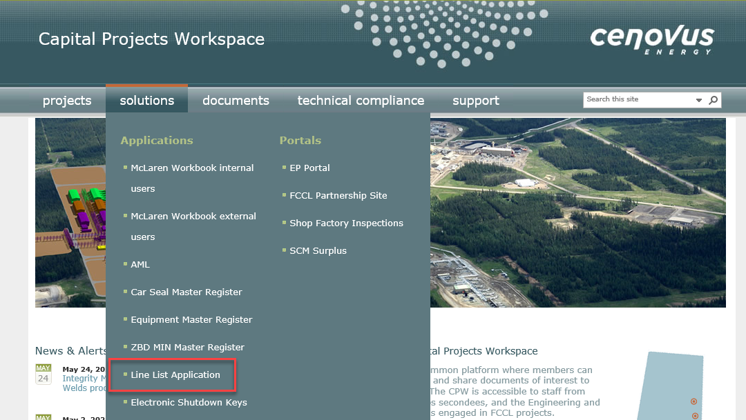

* 1. User Roles

**Note:** Within the scope of this document, the EP role also implies the Cenovus Field role, even if not explicitly stated. The EP role and Cenovus Field role have the same capabilities (for different projects).

All users can search for issued Line Lists and Lines; however, only EP Users can reserve new Lines, edit and issue Line Lists that are assigned to their EP Company.

Line List Application supports the following User Roles who are assigned access privileges to perform the following functions:

Read Only

Read Only Users can search, filter and view Line Lists and Line data, and generate reports. All Users with access to the Capital Projects Workspace (CPW), including Cenovus employees and EP’s, are granted the Read Only role with no requirement to request specific access to the Line List Application.

**EP / Cenovus Field**

EP Users are EP staff with all the capabilities of a Read Only User. In addition, EP Users can reserve and manage Lines, and issue Line Lists for projects assigned to their EP Company.

Cenovus Field Users are Cenovus staff with the same capabilities as an EP User, but for projects assigned to them, e.g. MOC or PIM projects.

The EP User and Cenovus Field role is further delineated into the following roles:

* EP Administrator
* EP Lead Engineer
* EP Data Entry
* EP Reserve Lines

Each role can perform specific functions on a Project or Line List; see the Security Matrix below for more detail.

EP Administrators can request their required elevated access to the Line List Application by contacting the Cenovus Service Desk. The EP Administrator for the EP Company (or Cenovus Field Administrator for Cenovus Field) can provision EP Users (or Cenovus Field Users) with access to manage specific Projects in the Line List Application. That is, the EP Administrator can assign an EP User the EP Lead Engineer, EP Data Entry or EP Reserve Lines role on a Project in the Line List Application.

**Non-EP User**

Non-EP Users have either the Read Only role or one of the EP User roles for a different EP Company managing a Project. For example, if Project 0112 Phase 1C Expansion is managed by Vista-IMV Joint Venture, then any user (except Cenovus Administrator) that is not employed by Vista-IMV Joint Venture is assigned the Non-EP User role for Project 0112.

**Cenovus Administrators**

Cenovus Administrators are Cenovus employees that can perform all the functions of all User Roles for all projects, Line Lists and Lines. Administrators can manage lookup tables, e.g. facilities, projects, and Line parameters. In addition, they can perform security administration, e.g. add an EP Company to the Line List Application. Cenovus Administrators can request their required elevated access to the Line List Application by contacting the Cenovus Service Desk.

* 1. Security Matrix

Different permissions are assigned to Users based on the User Role they play in the application, and those permissions control access to screens, data and processes within the application. The following Security Matrix provides a list functions within the application for each User Role.

The following provides a description of each of the abbreviated headings in the Security Matrix:

* CVE ADM: Cenovus Administrator
* EP: Engineering and Procurement Company
* EP ADM: EP Administrator
* LEAD ENG: EP Lead Engineer
* EP DATA ENT: EP Data Entry
* EP RSV: EP Reserve Lines

| **FUNCTIONS** | **CVE**  **ADM** | **EP / CENOVUS FIELD** | | | | **READ ONLY** |
| --- | --- | --- | --- | --- | --- | --- |
| **ADM** | **LEAD ENG** | **DATA ENT** | **RSV** |
| Home Page | √ | √ | √ | √ | √ | √ |
| **Administration** | | | | | | |
| Manage Lookup Tables | √ |  |  |  |  |  |
| Manage Insulation Table Defaults | √ |  |  |  |  |  |
| Manage Concurrent Engineering | √ |  |  |  |  |  |
| **Project** | | | | | | |
| Project Collection | √ | √ | √ | √ | √ |  |
| Add a Project | √ | √ |  |  |  |  |
| Project Details | √ | √ | √ | √ | √ |  |
| Update a Project | √ |  | √ |  |  |  |
| Delete a Project | √ |  | √ |  |  |  |
| Project Turnover | √ | √ |  |  |  |  |
| Project Role Collection | √ | √ | √ | √ | √ |  |
| Add a Project Role | √ | √ |  |  |  |  |
| Update Project Roles | √ | √ |  |  |  |  |
| Delete a Project Role | √ | √ |  |  |  |  |
| Project Insulation Table Defaults Details | √ | √ | √ | √ | √ |  |
| Edit a Project Insulation Table Defaults | √ |  | √ |  |  |  |
| **Line List** | | | | | | |
| Line List Search | √ | √ | √ | √ | √ | √ |
| Line List Export | √ | √ | √ | √ | √ | √ |
| Line List Details | √ | √ | √ | √ | √ | √ |
| Add a Line List | √ |  | √ | √ |  |  |
| Update a Line List | √ |  | √ | √ |  |  |
| Change Line List Status | √ |  | √ | √ |  |  |
| Print a LDT for review | √ | √ | √ | √ | √ |  |
| Print a LDT for reference | √ | √ | √ | √ | √ | √ |
| Print and Issue a Line List | √ |  | √ | √ |  |  |
| Up Rev a Line List | √ |  | √ | √ |  |  |
| Discard a Draft | √ |  | √ | √ |  |  |
| Line List – View Lines | √ | √ | √ | √ | √ | √ |
| Line List – Reserve Lines | √ |  | √ | √ | √ |  |
| Line List – Include Existing Lines | √ |  | √ | √ | √ |  |
| Line List – Include Reference Lines | √ |  | √ | √ | √ |  |
| Line List – Check Out Lines | √ |  | √ | √ | √ |  |
| Line List – Move Line to Another Line List | √ |  | √ | √ | √ |  |
| Line List – Copy Line Data | √ |  | √ | √ |  |  |
| Line List – Create a Child Line | √ |  | √ | √ |  |  |
| Line List – Update a Line | √ |  | √ | √ |  |  |
| Line List – Discard a Line | √ |  | √ | √ |  |  |
| Line List – Delete a Line | √ |  | √ | √ |  |  |
| Line List – Edit Lines in Grid | √ |  | √ | √ |  |  |
| Line List – Concurrent Engineering | √ |  | √ | √ |  |  |
| **Line Database Search** | | | | | | |
| Search for Lines | √ | √ | √ | √ | √ | √ |
| Export Lines | √ | √ | √ | √ | √ | √ |
| Navigate to Line List | √ | √ | √ | √ | √ | √ |
| Line Details | √ | √ | √ | √ | √ | √ |

* 1. Security Trimming

Security Trimming ensures that only EP Users can view all information for Lines and Line Lists that have not yet been Issued for Construction (IFC) by their EP Company. Non-EP Users can only view a subset of information for Lines and Line Lists that have not yet been Issued for Construction (IFC), e.g. can view EP Company, Line Number, Document Number. Non-EP Users are required to contact the managing EP Company directly if they require confidential information for a Line or Line List that is security trimmed in the Line List Application.

**Note:** Security Trimming may hide buttons, functions or information within the application from view; consequently, actual screens within the application may not be displayed exactly as shown on screen prints within this document.

1. Navigating the Interface
   1. Navigation Tabs

Navigation tabs, displayed at the top of every screen within the Line List Application, allow you to navigate to different sections of the application.

**Note:** Security Trimming may hide a navigation tab from a User Role.

* To navigate the interface

1. Click on one of the navigation tabs

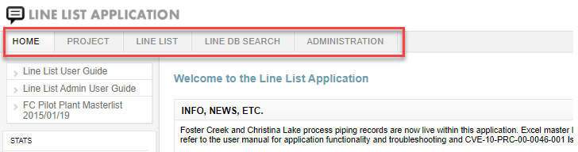

The Line List Application interface is made up of the following navigation tabs:

**Home**

* A starting point and logout for the application.
* Provides user identification, Line List news and links to related applications.
* Can send an email to the Line List team requesting help or providing suggestions.
* Can view and print a copy of the User Guide (this document).

**Project**

* A Project is a scope of work executed by either an Engineering & Procurement Company or by Cenovus Field at one Facility.
* A Project may contain one or many Line Lists.
* A Project may have a set of tables to default engineering data for Lines.
* A Project may have a list of Users assigned EP Roles (Lead Engineer, Data Entry, and Reserve Lines).

**Line List**

* A Line List is a collection of new and/or existing Lines.
* A Line List may have many revisions during its lifecycle, from initial design to redesign and construction.
* A Line List can be printed as a Line Designation Table (LDT) for review or publication.

**Line DB Search**

* A Line is a piece of pipe within a pressure piping system that is uniquely identified by a Line Number.
* A Line may have many revisions during its lifecycle, from initial design to redesign and construction.
* A Line may be active on more than one Line List during concurrent engineering.

**Administration**

* Only Cenovus Administrators can manage supporting information, e.g. Lookup Tables, for Lines and Line Lists.
* Only Cenovus Administrators can manage multiple active revisions of a Line.
  1. Sorting and Filtering Results

Collection screens throughout the Line List Application display a list of results, e.g. a collection of Projects. The results can be sorted and filtered to suit your preferences.

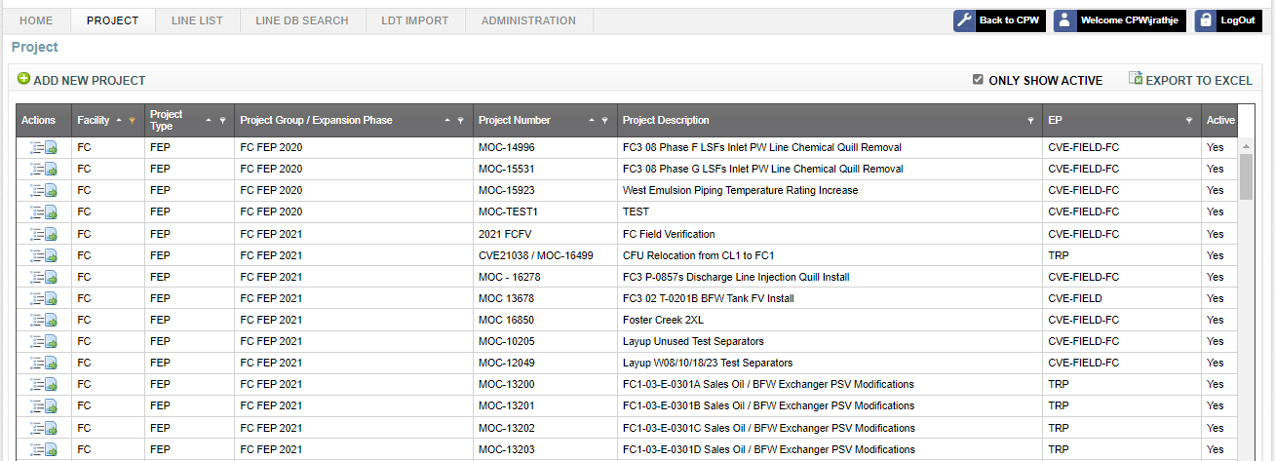

* To sort your results

1. Click on any column heading, except for the Actions column, to sort your results by that column.

The default sort is ascending. The ascending sort order is depicted by a black triangle pointing upwards which appears to the right of the attribute name.  
  


1. Click again and the sort changes to descending, depicted with a black triangle pointing down.

Note: You can only sort by one column at any given time.

* To fine tune your results

At the top of each column to the right of the attribute name, is a button which you can use to filter your results for that selected column.

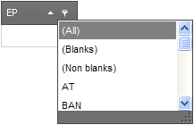

1. On the column you wish to filter, click on the **filter** button.
2. Select a value within the drop-down.

Line List Application refreshes the search results based on your filter property. The filtered column is depicted by an orange colored **filter** button.

Note: If you want to filter on more than one column, repeat this action for each column you wish to filter on. Line List Application will refresh with each filtering, narrowing your content as you progress.

1. Project

The Project tab provides Engineering & Procurement Companies the capability to manage their Projects. A Project is a scope of work executed by either an Engineering & Procurement Company or by Cenovus Field at one Facility.

Note: Security Trimming will hide the Project tab from Read Only Users.

* 1. Project Collection

The Project Collection function lists the collection of Projects for an EP Company.

EP Users have security permissions to perform this function for Projects belonging to their EP Company. Cenovus Administrators can perform this function for any Project.

To view a Collection

1. Click the **Project** navigation tab.

The collection of Projects for the currently logged in EP User is displayed.

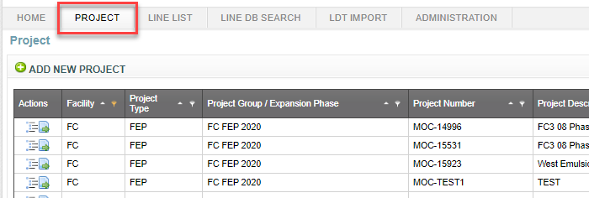

1. See the Sorting and Filtering Results section of this document for additional capabilities.

Note: Cenovus Administrators will see the collection of Project for all EP’s, along with an EP column.

* 1. Project Export

The Project Export function saves a collection of Projects in a Microsoft Excel spreadsheet for immediate analysis.

EP Users have security permissions to perform this function for Projects belonging to their EP Company. Cenovus Administrators can perform this function for any Project.

* To export to a spreadsheet

1. Click the **Project** navigation tab.
2. Click **Export to Excel** to open a Microsoft Excel spreadsheet populated with your collection of Projects.

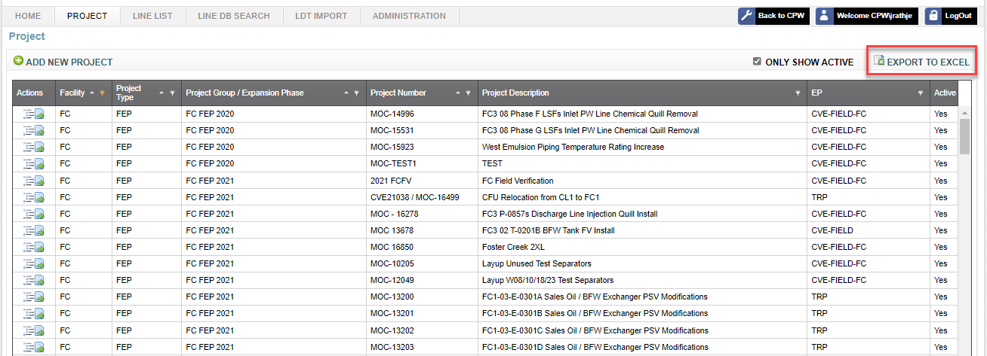

1. Review and assess the information.

**Note**: You cannot export an empty search. Data needs to be present.

* 1. Project Line Lists

The Project Line Lists function lists the collection of Line Lists for a Project. A Project may contain one or many Line Lists.

EP Users have security permissions to perform this function for Projects belonging to their EP Company. Cenovus Administrators can perform this function for any Project.

* To view Line Lists

1. Click the **Project** navigation tab.
2. Click **Line List** action for the desired Project.

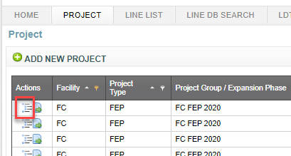

The collection of Line Lists for the desired Project is displayed.

**Note**: Refer to the Line Lists section of this document for a description of functions for Line Lists.

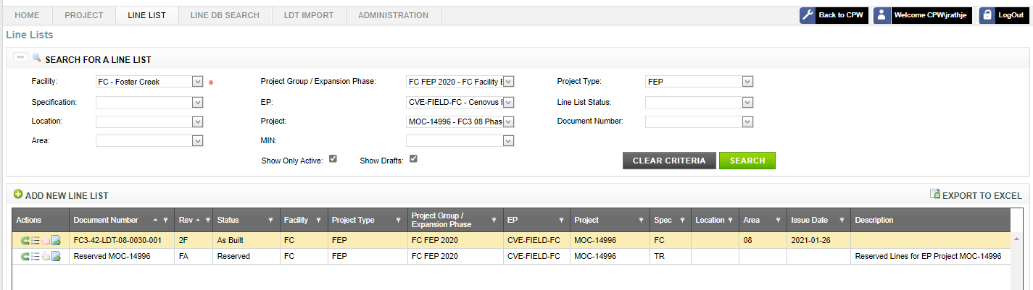

* 1. Project Details

The Project Details function provides more information for a Project.

EP Users have security permissions to perform this function for Projects belonging to their EP Company. Cenovus Administrators can perform this function for any Project.

* To view details

1. Click the **Project** navigation tab.
2. Click **Details** actionfor the desired Project.

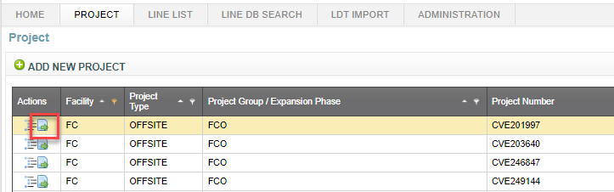

A window is opened with detailed information for the selected Project.

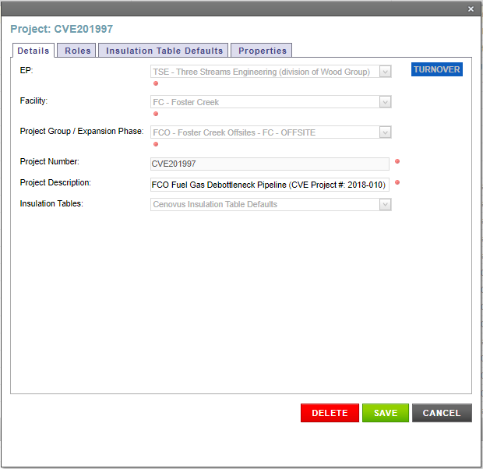

* 1. Add a Project

The Add a Project function creates a new Project. Thereafter, Line Lists can be added to a Project.

EP Administrators have security permissions to add a Project for their own EP Company. Cenovus Administrators can add a Project for any EP Company.

* To add a Project

1. Click the **Project** navigation tab.
2. Click **Add New Project** to open a window for data entry.

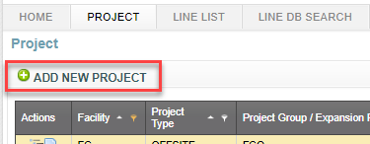

1. Complete all required information on the Details tab.
2. Click **Save** to create the new Project.

The Project is created. As well, a set of Insulation Table Defaults and a Reserved Line List is automatically created for the new Project.

* 1. Update a Project

The Update a Project function updates information for an existing Project.

EP Lead Engineers have security permissions to update a Project for their own EP Company. Cenovus Administrators can update any Project.

* To update Project details

1. Click the **Project** navigation tab.
2. Click **Details** actionfor the desired Project.
3. Update information on the Details tab.
4. Click **Save** to apply your changes.

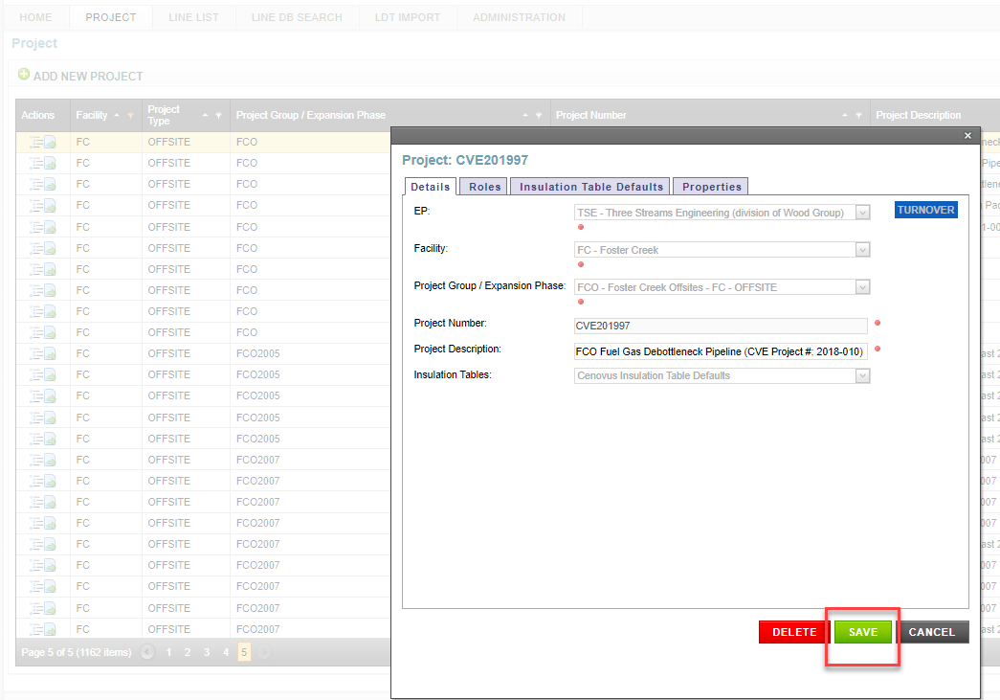

* 1. Delete a Project

The Delete a Project function removes an existing Project from the Line List Application.

EP Lead Engineers have security permissions to delete a Project for their own EP Company. Cenovus Administrators can delete any Project.

This function can only be performed under the following conditions:

* Reserved Line List for the Project has no reserved Lines
* Project has no other Line Lists
* To delete a Project

1. Click the **Project** navigation tab.
2. Click **Details** actionfor the desired Project.
3. Click **Delete**.
4. Click **OK** to confirm.

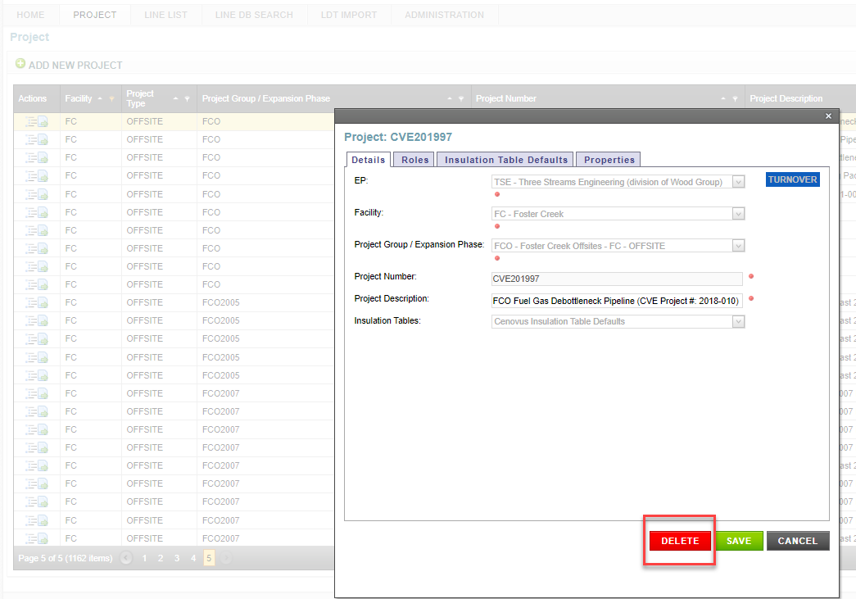

The Project is deleted.

* 1. Project Turnover

The Project Turnover function changes ownership for a Project to support the following business processes:

* When ownership of the project is changed from one EP to another EP
* When Cenovus Field is required to complete the As Built process for the Line Lists belonging to a Project

EP Administrators have security permissions to turnover a Project for their own EP Company to Cenovus Field. Cenovus Administrators can turnover any Project to any EP Company or Cenovus Field.

This function can only be performed under the following conditions:

* All Line Lists belonging to the Project are in an Issued state, i.e. not in Draft
* The Reserved Line List for the Project has no reserved Lines
* To turnover a Project

1. Click the **Project** navigation tab.
2. Click **Details** actionfor the desired Project.
3. Click **Turnover**.
4. Select a **To EP** from the drop-down text box.
5. Click **Save.**

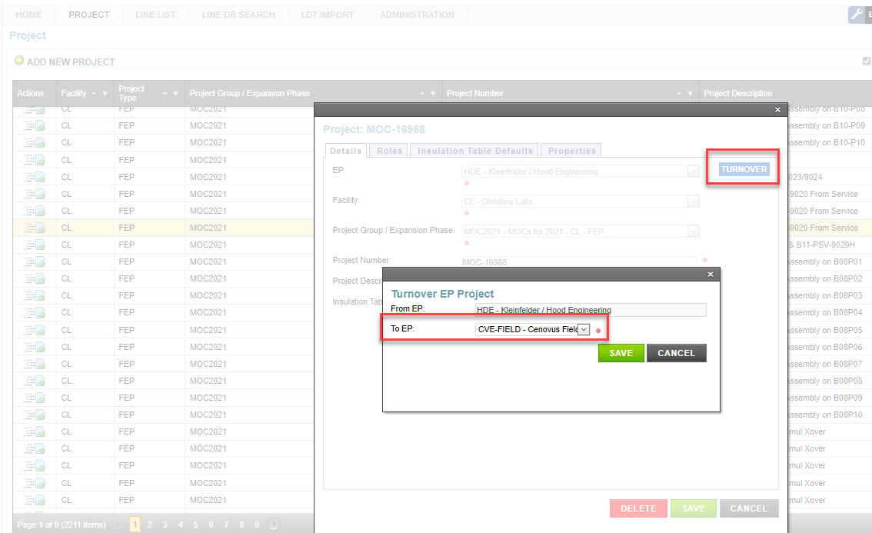

The Project is turned over to the selected EP or Cenovus Field. E-mail notifications are sent to the EP Administrator(s) for both the previous EP and the new EP or Cenovus Field.

* 1. Insulation Table Defaults

Insulation Table Defaults can be used to provide default values for Insulation Thickness and Tracing Design Number of Tracers when given other Line attributes. Every Project has a set of Insulation Table Defaults that are created when the Project is created, and can later be modified.

* + 1. Insulation Table Default Collection

The Insulation Table Default Collection function lists a collection of Insulation Table Defaults for a Project.

EP Users have security permissions to perform this function for Projects belonging to their EP Company. Cenovus Administrators can perform this function for any Project.

* To view a collection

1. Click the **Project** navigation tab.
2. Click **Details** action for the desired Project.
3. Click **Insulation Table Defaults** tab.

The collection of Insulation Table Defaults for the desired Project is displayed.

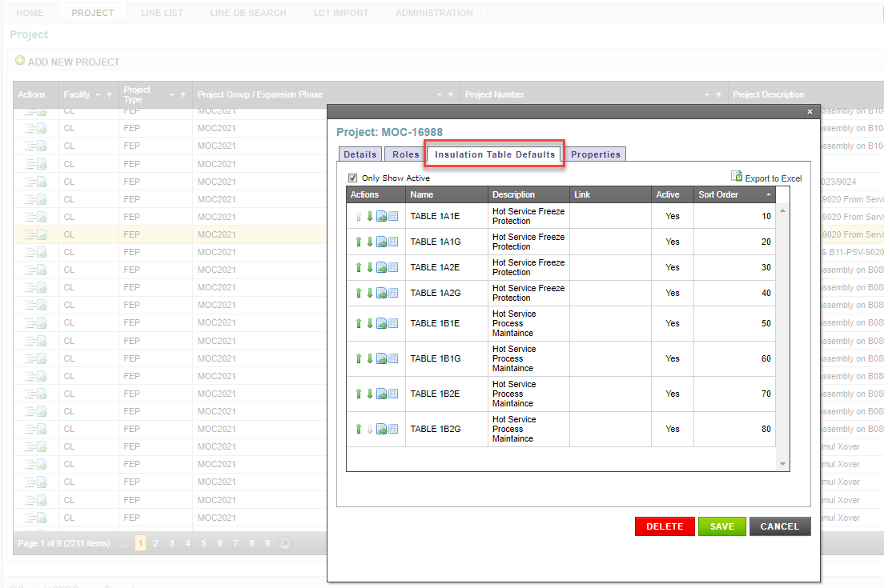

* + 1. Insulation Table Default Details

The Insulation Table Default Details function provides more information for an Insulation Table Default.

EP Users have security permissions to perform this function for Projects belonging to their EP Company. Cenovus Administrators can perform this function for any Project.

* To view Insulation Table Default details

1. Click the **Project** navigation tab.
2. Click **Details** actionfor the desired Project.
3. Click **Insulation Table Defaults** tab.

The collection of Insulation Table Defaults for the desired Project is displayed.

1. Click **Details** actionfor the desired Insulation Table Default.

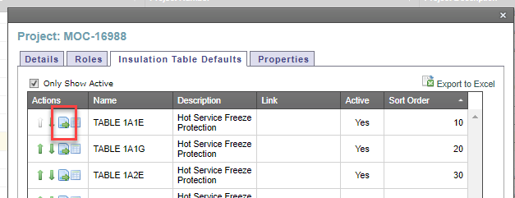

A window is opened with detailed information for the desired Insulation Table Default.

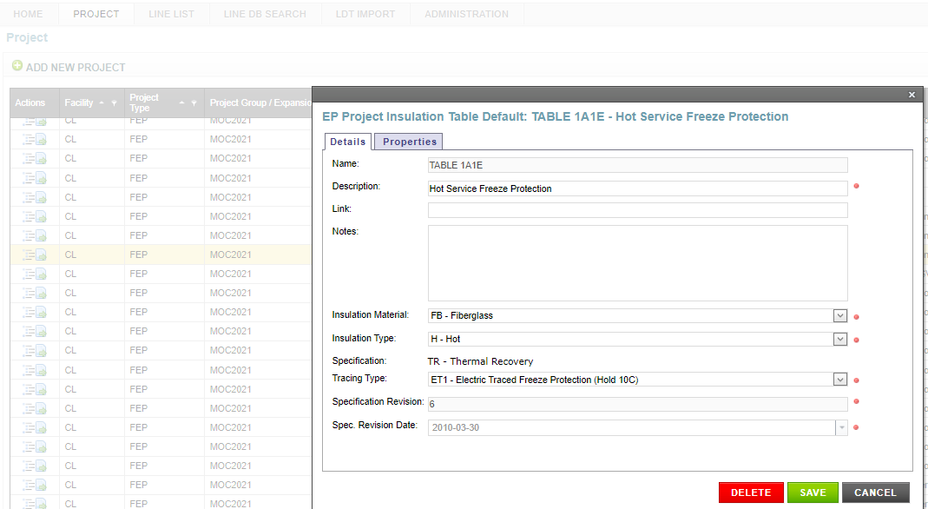

* + 1. View an Insulation Table Default

The View an Insulation Table Default function views table values for an Insulation Table Default.

EP Users have security permissions to perform this function for Projects belonging to their EP Company. Cenovus Administrators can perform this function for any Project.

* To view

1. Click the **Project** navigation tab.
2. Click **Details** actionfor the desired Project.
3. Click **Insulation Table Defaults** tab.

The collection of Insulation Table Defaults for the desired Project is displayed.

1. Click **Table** actionfor the desired Insulation Table Default.

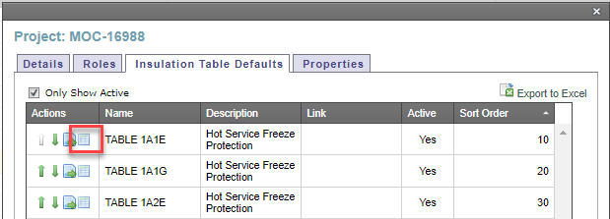

A window is opened with table values for the desired Insulation Table Default.

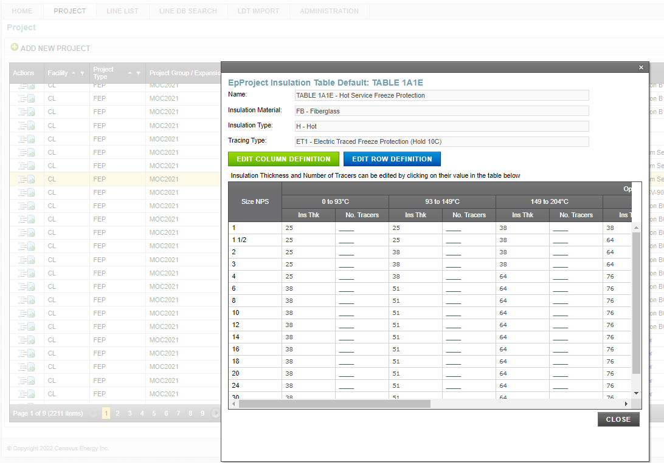

* + 1. Edit an Insulation Table Default

The Edit an Insulation Table Default function changes values for an Insulation Table Default.

EP Lead Engineers have security permissions to perform this function for a Project for their own EP Company. Cenovus Administrators can perform this function for any Insulation Table Defaults.

* To edit

1. Click the **Project** navigation tab.
2. Click **Details** actionfor the desired Project.
3. Click **Insulation Table Defaults** tab.

The collection of Insulation Table Defaults for the desired Project is displayed.

1. Click **Table** actionfor the desired Insulation Table Default.

A window is opened with table values for the desired Insulation Table Default.

1. Click **Edit Column Definition** to edit the column definitions for Operating Temperature ranges.

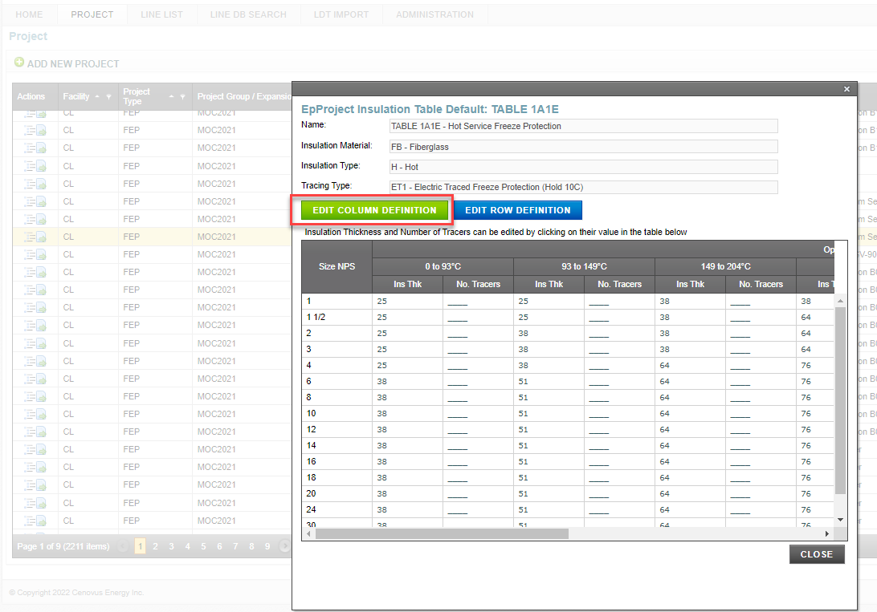

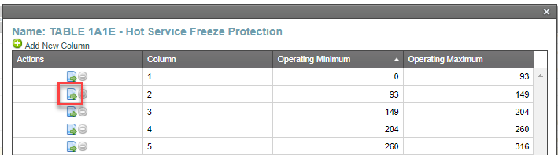

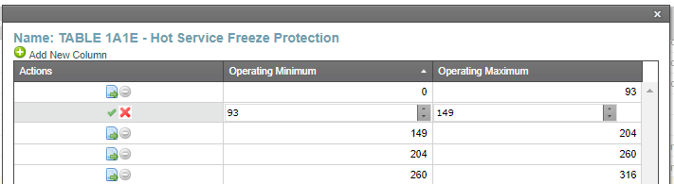

Click the green check mark to save changes.

1. Click **Edit Row Definition** to edit row definitions for Size NPS.

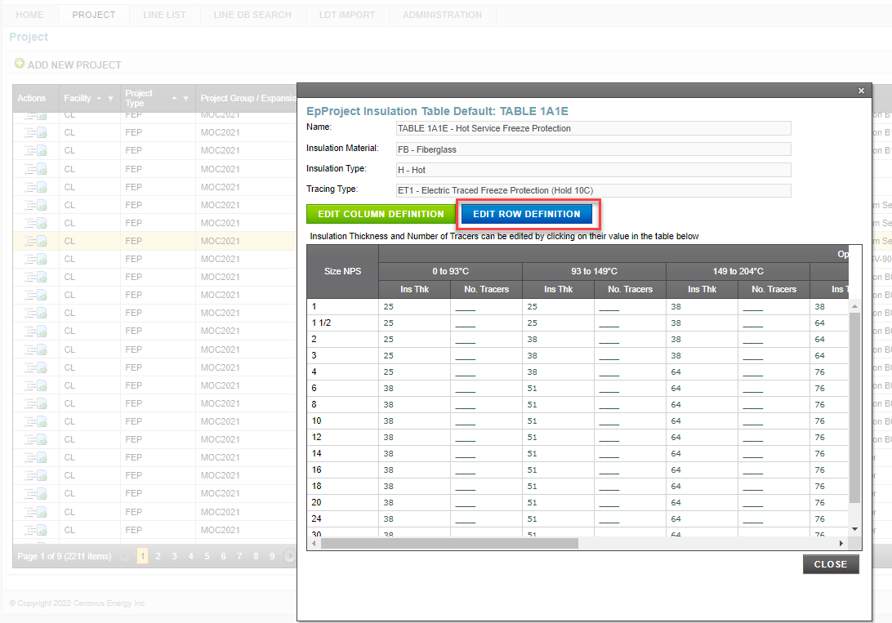

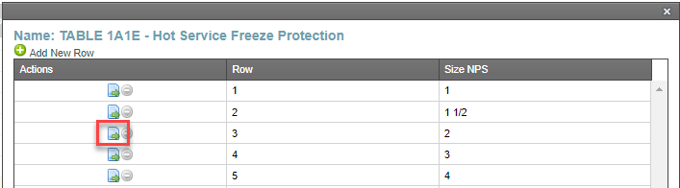

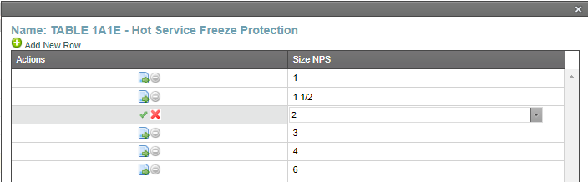

Click the green check mark to save changes.

1. Click any table value to edit Insulation Thickness or Number of Tracers.

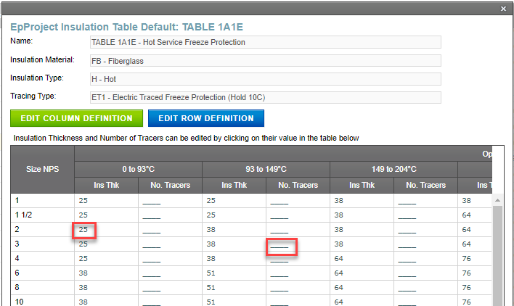

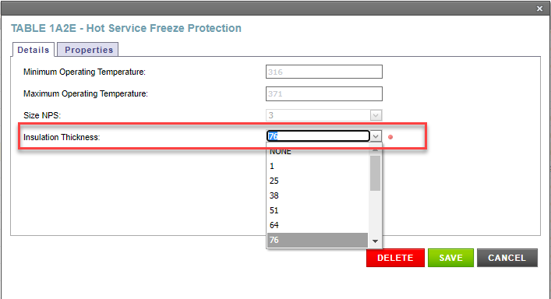

* 1. Project Roles

The EP Administrator for the EP Company (or Cenovus Field Administrator for Cenovus Field) can provision EP Users (or Cenovus Field Users) with access to manage specific Projects and Line Lists in the Line List Application. Cenovus Administrators can assign roles for any Project and EP Company.

Within the Line List Application, the following Project Roles can be assigned to a User:

* EP Lead Engineer
* EP Data Entry
* EP Reserve Lines

Each role can perform specific functions on an Project or Line Lists belonging to the Project; see the Security Matrix section of this document for more detail.

**Note:** The EP Administrator role is provisioned by the Cenovus Service Desk, i.e. is not provisioned within the Line List Application.

* + 1. Project Role Collection

The Project Role Collection function lists the collection of Users that are assigned roles on a Project.

EP Users have security permissions to perform this function for Projects belonging to their EP Company. Cenovus Administrators can perform this function for any Project.

* To view a collection

1. Click the **Project** navigation tab.
2. Click **Details** action for the desired Project.

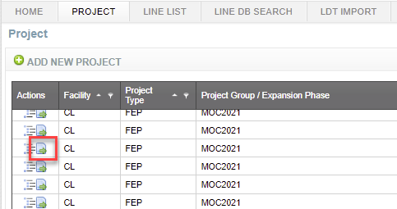

1. Click **Roles** tab.

The collection of Roles assigned to individuals for the desired Project is displayed.

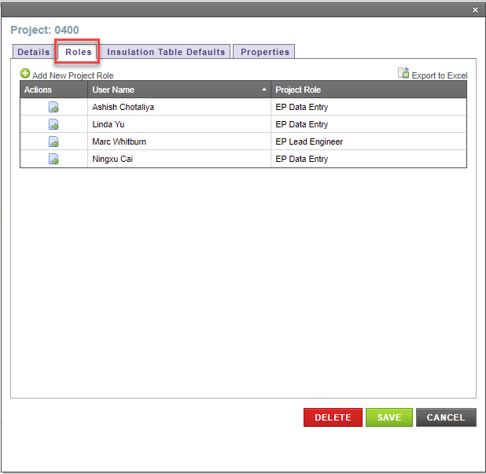

* + 1. Add a Project Role

The Add a Project Role function adds a User to a Project and assign him/her a specific role.

EP Administrators have security permissions to perform this function for Projects belonging to their EP Company. Cenovus Administrators can perform this function for any Project.

* To add a Project Role

1. Click the **Project** navigation tab.
2. Click **Details** action for the desired Project.
3. Click **Roles** tab.

The collection of Roles assigned to individuals for the desired Project is displayed.

1. Click **Add New Project Role** to open a window for data entry.

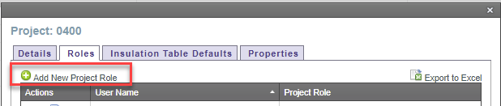

1. Complete all required information.
2. Click **Save** to create the new Project Role.

The selected individual is assigned the new Project Role.

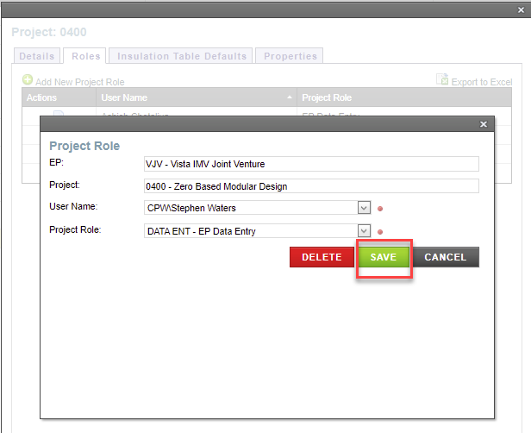

* + 1. Update a Project Role

The Update a Project Role function updates the existing Roles assigned to an individual for a Project.

EP Administrators have security permissions to perform this function for Projects belonging to their EP Company. Cenovus Administrators can perform this function for any Project.

* To update a Project Role

1. Click the **Project** navigation tab.
2. Click **Details** actionfor the desired Project.
3. Click **Roles** tab.

The collection of Roles for the desired Project is displayed.

1. Click **Details** actionfor the desired Project Role.

A window is opened with detailed information for the desired Project Role.

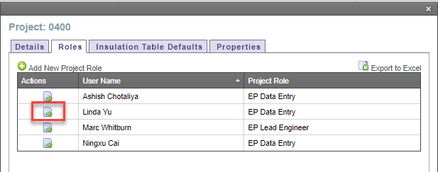

1. Select User Name and/or Project Role from the drop-down text boxes.
2. Click **Save** to apply your changes.

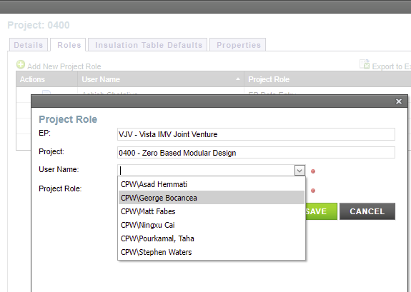

* + 1. Delete a Project Role

The Delete a Project Role function deletes an existing Role assigned to an individual for a Project.

EP Administrators have security permissions to perform this function for Projects belonging to their EP Company. Cenovus Administrators can perform this function for any Project.

* To delete a Project Role

1. Click the **Project** navigation tab.
2. Click **Details** actionfor the desired Project.
3. Click **Roles** tab.

The collection of Roles for the desired Project is displayed.

1. Click **Details** actionfor the desired Project Role.

A window is opened with detailed information for the desired Project Role.

1. Click **Delete**.

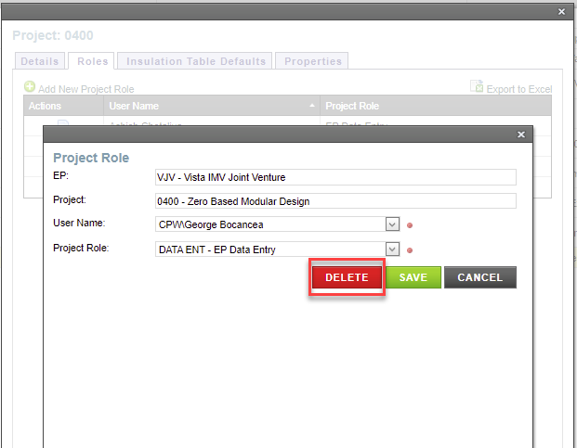

1. Line List

The Line List tab allows you to search, view and manage Line Lists. A Line List has the following characteristics:

* A Line List is a collection of new and/or existing Lines.
* A Line List may have many revisions during its lifecycle, from initial design to redesign and construction.
* A Line List can be printed as a Line Designation Table (LDT) for review or publication.
  1. Line List Search

The Line List Search function searches for Line Lists based on a single modifier or number of modifiers to return more focused results.

All CPW Users and all Line List Application users have security permission to perform this function. However, only EP Users and Cenovus Administrators can perform this function for a Line List that is in a Draft state.

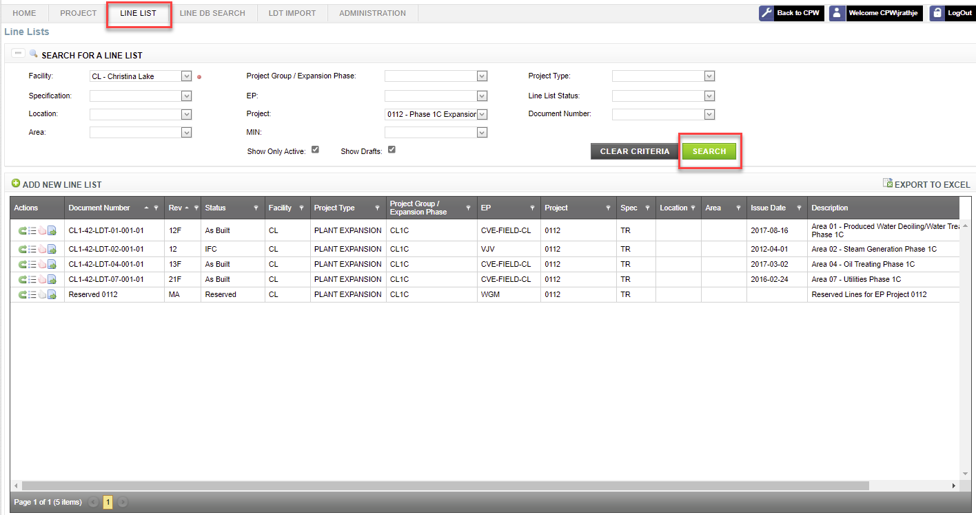

For instance, you can search on the Christina Lake facility and get all Line Lists related to that facility. Narrowing down your search by adding more parameters brings better results while still allowing for great flexibility. You can use information like Project Type or EP to return more focused results.

* To conduct a search

1. Click the **Line List** navigation tab.
2. Select your search criteria from the drop-down text boxes.

Note: Drop-down text boxes are automatically filtered based on search criteria already specified, e.g. after selecting Christina Lake facility, only locations within Christina Lake can be selected. Auto-complete also offers suggestions as you type.

1. If you want to search for all revisions of a Line List, de-select **Show Only Active** checkbox.

**Note:** A Line List may have many revisions during its lifecycle, from initial design to redesign and construction. The **Rev** column identifies the Revision and the **Status** column identifies the lifecycle stage for a **Document Number**.

1. If you want to search for revisions of a Line List that are still in a Draft state and have not yet been Issued, select **Show Drafts** checkbox.
2. Click **Search**.

The results are displayed.

If your search is successful, information will display; otherwise, the results area will remain empty. The Search Results area displays the number of Line Lists (records) that meet your search criteria.

1. See the Sorting and Filtering Results section of this document for additional capabilities.

Note: You can show or hide your search criteria by clicking **Show/Hide Search Panel**.

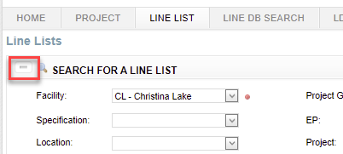

* 1. Export Line Lists

The Export Line Lists function saves your search results in a Microsoft Excel spreadsheet for immediate analysis.

All CPW Users and all Line List Application users have security permission to perform this function. However, Security Trimming may hide buttons, functions or information within the application from view.

* To export to a spreadsheet

1. Conduct a search. See the Line List Search section of this document.
2. Click **Export to Excel** to open a Microsoft Excel spreadsheet populated with your full search results.

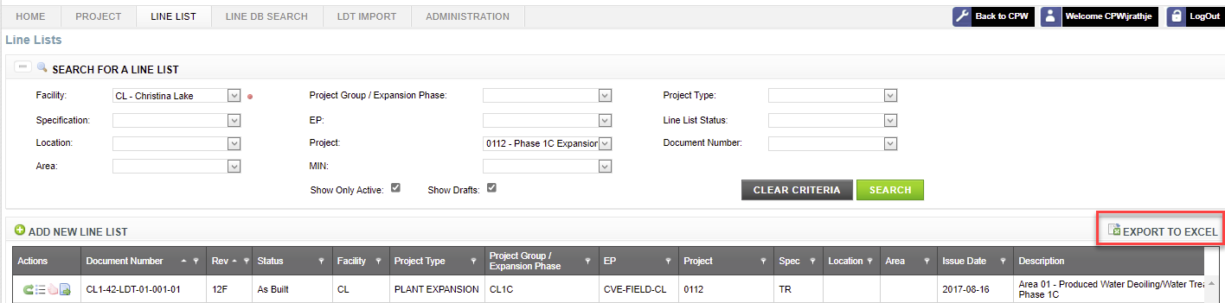

**Note**: You cannot export an empty search. Data needs to be present.

* 1. Line List Details

The Line List Details function provides more information for a Line List.

All CPW Users and all Line List Application users have security permission to perform this function. However, Security Trimming may hide buttons, functions or information within the application from view.

* To view Line List details

1. Conduct a search. See the Line List Search section of this document.
2. Click **Details** actionfor the desired Line List.

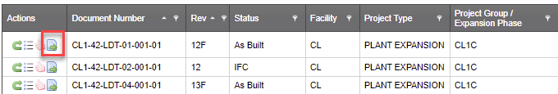

A window is opened with detailed information for the Line List, i.e. information that is typically displayed on the cover page of an LDT.

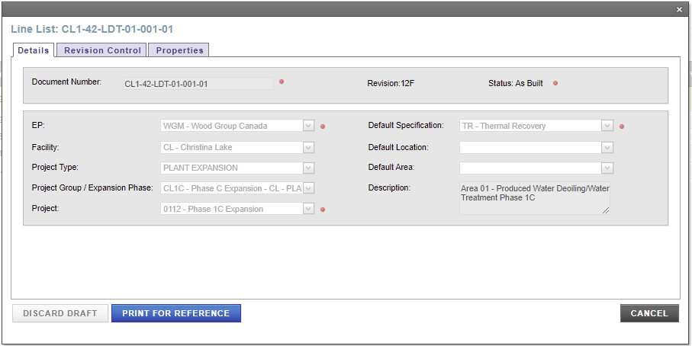

1. Click any tab for additional information.

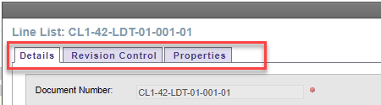

* 1. Add a Line List

The Add a Line List function creates a new Line List. All new Line Lists must be added to an existing Project.

EP Lead Engineers and EP Data Entry roles for a Project have security permissions to add a Line List. Cenovus Administrators can add a Line List to any Project.

* To add a Line List

1. Click the **Line List** navigation tab.
2. Click **Add New Line List** to open a window for data entry.

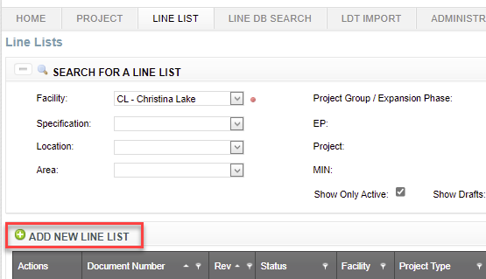

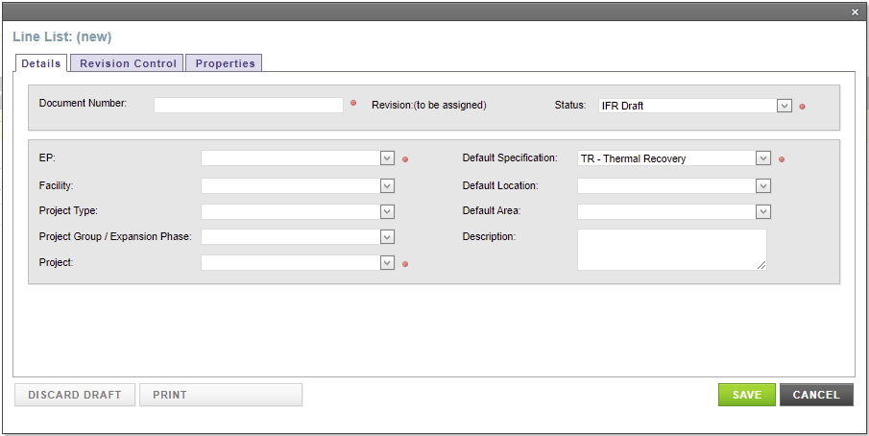

Complete all required information on the Details tab, i.e. information that is typically displayed on the cover page of an LDT.

**Note**: EP’s are responsible for acquiring a Document Number from McLaren as outlined in [CVE-10-JI-00-0009-001](https://cpw.cenovus.com/projects/EIM/Governing%20Documents/CVE-10-JI-00-0009-001%20%20Request%20Engineering%20Placeholders%20-%20McLaren.pdf) Request Engineering Placeholders - McLaren . Revision Numbering is assigned by the Line List Application.

1. Click **Save** to create the new Line List.

The Line List is created.

* 1. Update a Line List

The Update a Line List function updates information of an existing Line List, i.e. information that is typically displayed on the cover page of an LDT.

EP Lead Engineers and EP Data Entry roles for an Project have security permissions to perform this function. Cenovus Administrators can perform this function for any Line List.

This function can only be performed under the following conditions:

* Line List is in a Draft state.
* Line List is not locked. See the Line List Print for Issue section of this document.

**Note:** Revisions of a Line List that have been previously issued cannot be updated. If a previous revision of the Line List has been issued, only the Line List Description can be updated on the current draft revision.

* To update Line List details

1. Conduct a search. See the Line List Search section of this document.
2. Click **Details** actionfor the desired Line List.

Update information on the Details tab, i.e. information that is typically displayed on the cover page of an LDT.

1. Click **Save** to apply your changes.

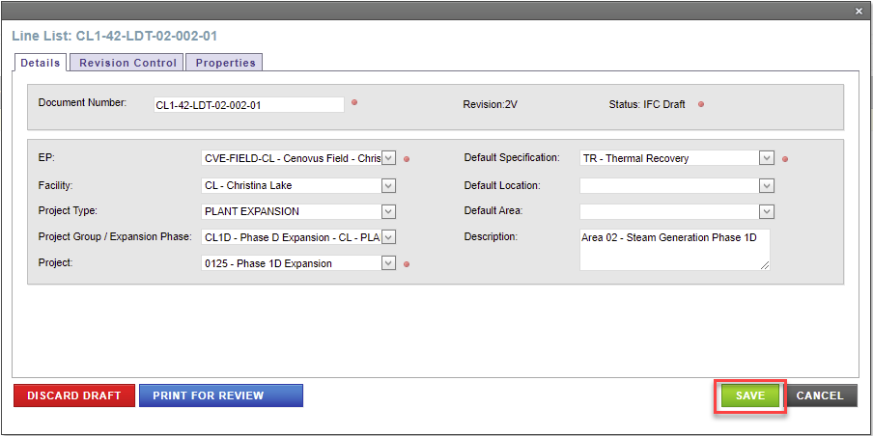

* 1. Change Line List Status

The Change Line List Status function moves a Line List to a different lifecycle stage. For example, if Issued for Review is determined not to be required, the Line List can be moved to Issued for Approval.

EP Lead Engineers and EP Data Entry roles for a Project have security permissions to change the status for a revision of a Line List. Cenovus Administrators can change the status for a revision of a Line List for any Project.

This function can only be performed under the following conditions:

* Line List is in a Draft state.
* Line List is not locked. See the Line List Print and Issue section of this document.

**Note:** Revisions of a Line List that have been previously issued cannot be changed.

* To change status

1. Conduct a search. See the Line List Search section of this document.
2. Click **Details** actionfor the desired Line List.
3. Click **Revision Control** tab.
4. Select the new Status from the drop-down text box in the **Change Status** section of the screen.

**Note:** Rules governing the lifecycle of a Line List determine which Statuses are available in the drop-down text box, e.g. a Line List cannot be Issued for Review (or re-issued) after Issued for Approval.

1. Click **Save** to apply your changes.

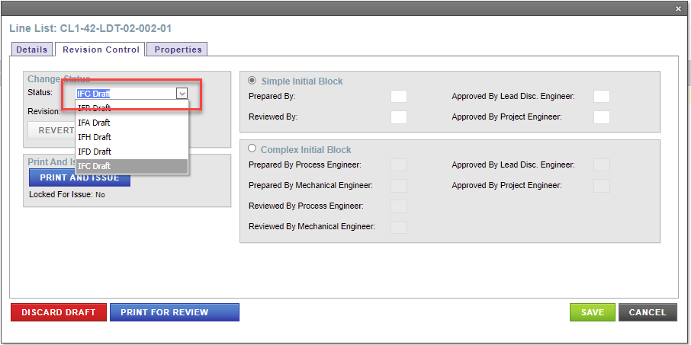

* 1. Print for Review

The Print for Review function generates an LDT with a DRAFT watermark (in Adobe PDF format) to be circulated for reviewing. This function generates the Cover Page of an LDT with a blank Issue Date.

**Note:** EP’s are responsible for following Cenovus Procedure CVE-10-PRC-00-0046-001 Issuing a Line Designation Table.

EP Lead Engineers and EP Data Entry roles for a Project have security permissions to perform this function. Cenovus Administrators can perform this function for any Line List.

This function can only be performed under the following conditions:

* Line List is in a Draft state.
* PRINT AND ISSUE has not been performed.
* Line List is not locked.
* To print a Line List for review

1. Create a new Line List or Up rev a Line List to a draft state. See “Add a Line List/ Up Rev a Line List” section of this document; Or conduct a search. See the Line List Search section of this document.
2. Click **Details** actionfor the desired Line List.
3. Click **Revision Control** tab.
4. Click **Print for Review**.

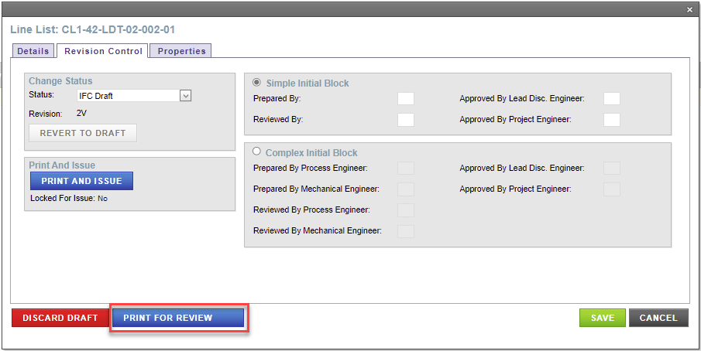

An LDT is generated in PDF format with a DRAFT watermark.

**Note:** A window might pop up to ask if to save edits. Click “OK” to continue.

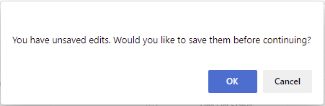

1. Before printing the LDT, set the print paper size to tabloid (11”x17”) to ensure the report prints to the correct paper size and change the paper orientation to landscape.
2. Print the LDT to your printer or to PDF.
   1. Print and Issue

The Print and Issue function generates an LDT with no watermark (in Adobe PDF format) for signing, stamping and issuing a hardcopy. This function generates the Cover Page of an LDT with Issue Date being populated.

**Note:** EP’s are responsible for following Cenovus Procedure CVE-10-PRC-00-0046-001 Issuing a Line Designation Table**.**

EP Lead Engineers and EP Data Entry roles for an Project have security permissions to issue a Line List. Cenovus Administrators can issue any Line List.

A revision of a Line List can be issued under the following conditions:

* Line List is in a Draft state.
* Required fields for the Line List and all Lines have assigned values.
* All Lines on the Line List are checked in.
* Line List is ready for issue after Print for Review.
* To print and issue a Line List

1. Create a new Line List or Up rev a Line List to a draft state. See “Add a Line List/ Up rev a Line List” section of this document; or conduct a search. See the Line List Search section of this document.
2. Click **Details** actionfor the desired Line List.
3. Click **Revision Control** tab.
4. Click **Print and Issue**.
5. Before printing the LDT, set the print paper size to tabloid (11”x17”) to ensure the report prints to the correct paper size and change the paper orientation to landscape.

**Note:** A window might pop up to ask if to save edits. Click “OK” to continue.



1. Print the LDT to your printer. A color printer is recommended, e.g. for viewing company logos on the cover page.

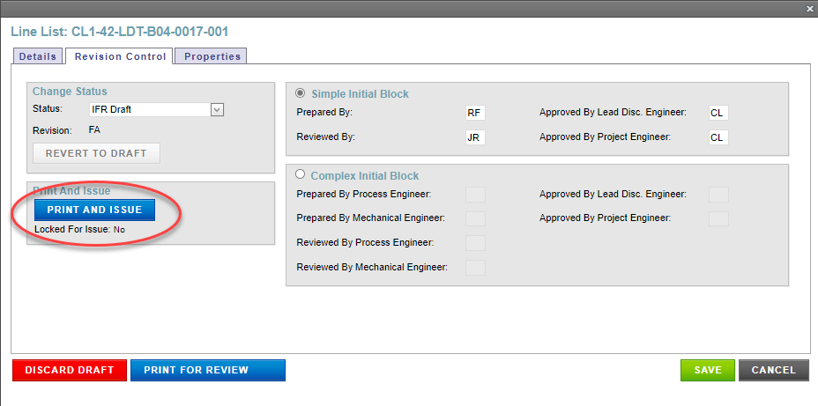

* 1. Print for Reference

The Print for Reference function views a Line List in a format outlined in **Line List Content and Format** section without a draft watermark after it has been printed and issued. This function does not generate the Cover Page of an LDT as print for reference is generates an uncontrolled copy of the LDT

**Note:** Refer to McLaren for signed and stamped copies of LDT documents submitted to EP/ Cenovus Document Control.

All CPW Users and all Line List Application users have security permission to perform this function. However, Security Trimming may hide information from view. As well, only EP Users and Cenovus Administrators can perform this function for a Line List that is in a Draft state.

This function can only be performed under the following conditions:

* Line List is not in a Draft state.
* PRINT AND ISSUE has been performed.
* To print a Line List for reference

1. Conduct a search. See the Line List Search section of this document.
2. Click **Details** actionfor the desired revision of a Line List.

**Note:** A Line List may have many revisions during its lifecycle, from initial design to redesign and construction. The **Rev** column identifies the Revision and the **Status** column identifies the lifecycle stage for a **Document Number**.

1. Click **Print for Reference** on the Details tab.

An LDT is generated in PDF format.

1. Before printing the LDT, set the print paper size to tabloid (11”x17”) to ensure the report prints to the correct paper size and change the paper orientation to landscape.
2. Print the LDT to your printer or to PDF.

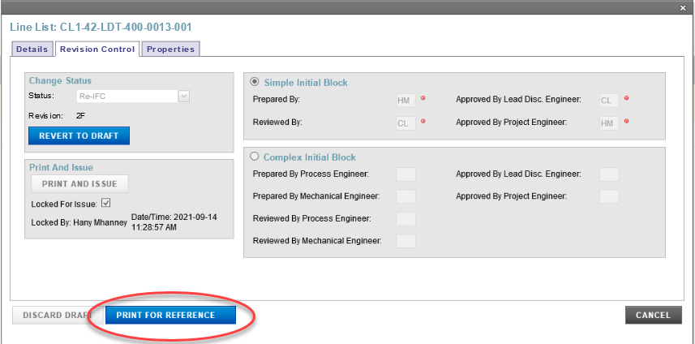

* 1. Up Rev a Line List

The Up Rev function creates a new revision of a Line List.

EP Lead Engineers and EP Data Entry roles for a Project have security permissions to up rev a Line List. Cenovus Administrators can up rev any Line List.

A Line List can be up revved under the following conditions:

* Line List is in an Issued state.
* To up rev a Line List

1. Conduct a search. See the Line List Search section of this document.
2. Click **Up Rev** actionfor the desired Line List.
3. Select the **Status** for new revision from the drop-down text box.

**Note:** Rules governing the lifecycle of a Line List determine which Statuses are available, e.g. a Line List cannot be up revved to Issued for Review - Draft after previously Issued for Approval.

1. Click **Save**.

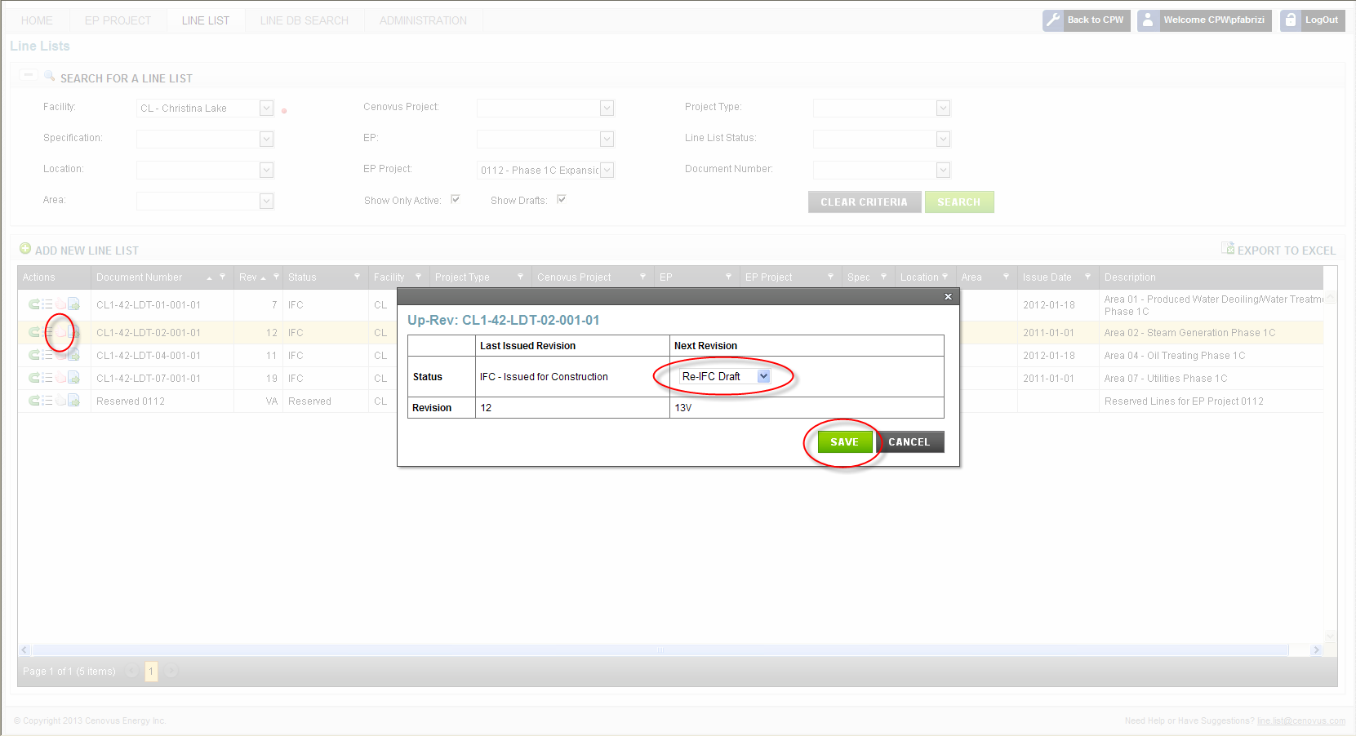

A new revision for the Line List is created in a Draft state, including all Lines on the previous revision.

* 1. Discard a Draft

The Discard a Draft function removes a revision of a Line List from the Line List Application.

EP Lead Engineers and EP Data Entry roles for a Project have security permissions to discard a draft Line List. Cenovus Administrators can discard any draft Line List.

This function can only be performed under the following conditions:

* Line List is in a Draft state.
* Line List is not locked.
* To discard a Line List

1. Conduct a search. See the Line List Search section of this document.
2. Click **Details** actionfor the desired Line List.
3. Click **Revision Control** tab.
4. Click **Discard Draft**.
5. Click **Yes** to confirm.

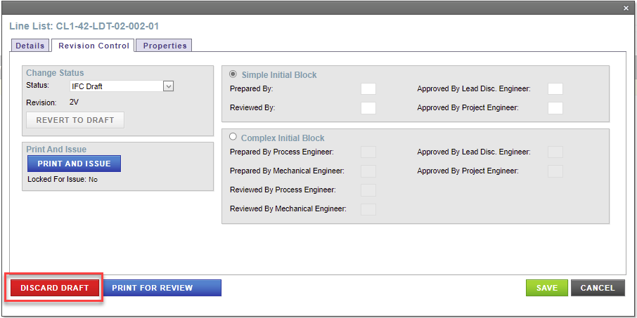

The draft revision of the Line List is discarded including all Lines on the revision. Once a revision is discarded, the Line List Application can no longer display or restore the revision. Revisions of the Line List that were previously issued remain unchanged.

* 1. Lines on a Line List

A Line List is a collection of new and existing Lines. Each Line has the following characteristics:

* A Line is a piece of pipe within a pressure piping system that is uniquely identified by a Line Number.
* A Line may have many revisions during its lifecycle, from initial design to redesign and construction.
* A Line may be active on more than one Line List during concurrent engineering.

The following sections provide a description of various functions for Lines on a Line List.

* + 1. View Lines

The View Lines function lists the collection of Lines on a Line List.

All CPW Users and all Line List Application users have security permission to perform this function. However, Security Trimming may hide buttons, functions or information within the application from view.

* To view lines

1. Conduct a search. See the Line List Search section of this document.
2. Click **Lines** actionfor the desired Line List.

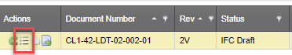

The list of Lines for the Line List is displayed.

1. See the Sorting and Filtering Results section of this document for additional capabilities.

**Note:** Reference Lines, displayed in the bottom section of the page, are not printed on the LDT.

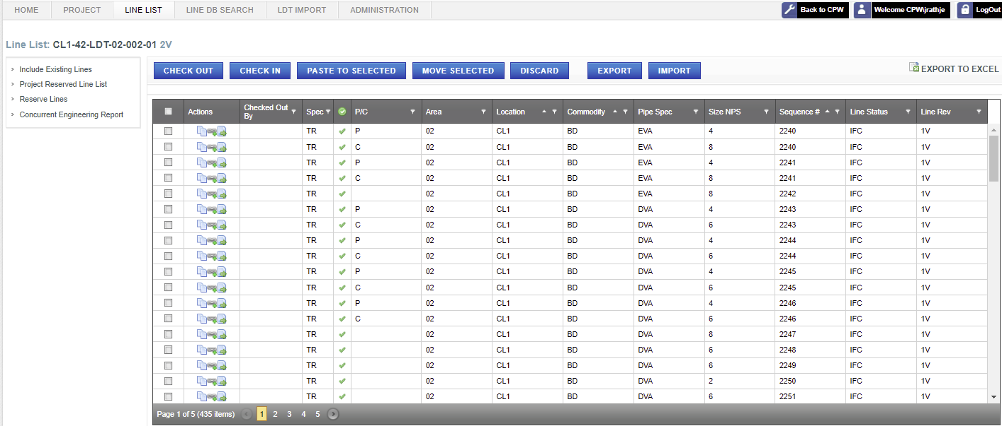

* To export to a spreadsheet

The Export function allows you to save your view of Lines in a Microsoft Excel spreadsheet for immediate analysis.

1. Click **Export to Excel** to open a Microsoft Excel spreadsheet populated with your full search results.

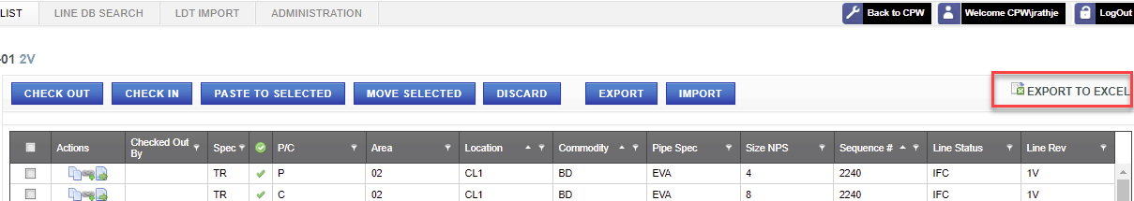

* + 1. Reserve Lines

The Reserve Lines function creates new Lines for a Line List. All new Lines must adhere to the TR Specification.

EP Lead Engineers, EP Data Entry and EP Reserve Lines roles for an Project have security permissions to reserve Lines. Cenovus Administrators can reserve Lines for any Line List.

This function can only be performed under the following conditions:

* Line List is in a Draft state, or,
* Project has a Reserved Line List (which is automatically created when an Project is created)

Reserved Lines must be added to an existing Line List. However, Lines can be temporarily added to the Reserved Line List for a Project and then later moved to a Line List on the Project (or discarded).

**Note:** Engineering data cannot be specified for Lines on the Reserved Line List; Lines must be moved to a regular Line List.

* To reserve lines

1. Conduct a search. See the Line List Search section of this document.
2. Click **Lines** actionfor the desired Line List.

The list of Lines for the Line List is displayed.

1. Click **Reserve Lines**.

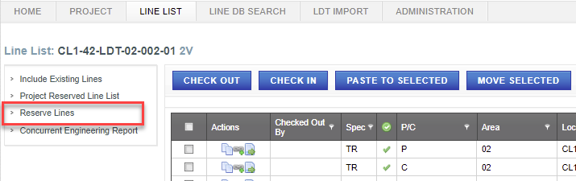

1. Complete all required information.

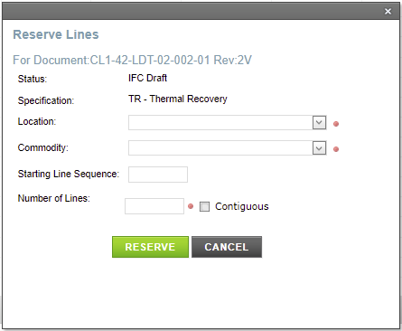

If **Starting Line Sequence** is left blank, Line List Application will reserve the lowest available set of Line Sequence Numbers.

If **Contiguous** is checked, Line List Application will reserve a block of Line Sequence Numbers in numerical sequence, e.g. 1001, 1002, 1003.

1. Click **Reserve**.

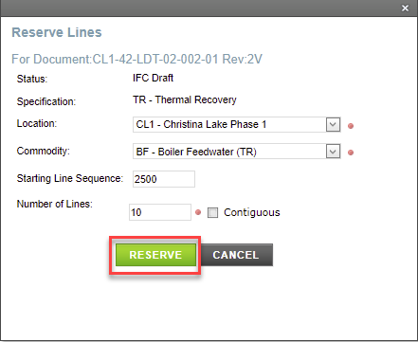

A new Line or group of Lines is created / reserved with unique Line Numbers and added to the selected Line List.

* + 1. Include Existing Lines

The Include Existing Lines function includes Lines on a Line List that were previously issued on a different Line List, e.g. if a PIM or MOC project is changing existing Lines.

EP Lead Engineers, EP Data Entry and EP Reserve Lines roles for an Project have security permissions to perform this function. Cenovus Administrators can perform this function for any Line List.

This function can only be performed under the following conditions:

* Line List is in a Draft state.
* Line List is not locked.
* To include existing lines

1. Conduct a search. See the Line List Search section of this document.
2. Click **Lines** actionfor the desired Line List.

The list of Lines for the Line List is displayed.

1. Click **Include Existing Lines**.

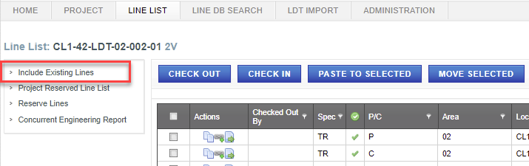

A list of Lines meeting the following criteria is displayed:

* Line belongs to the same Facility
* Line has been issued for a hard revision, e.g. IFC
* Line is active
* Line does not already exist on another Line List within the same Project

1. Select Lines to include using search criteria.
2. Click **Include**.

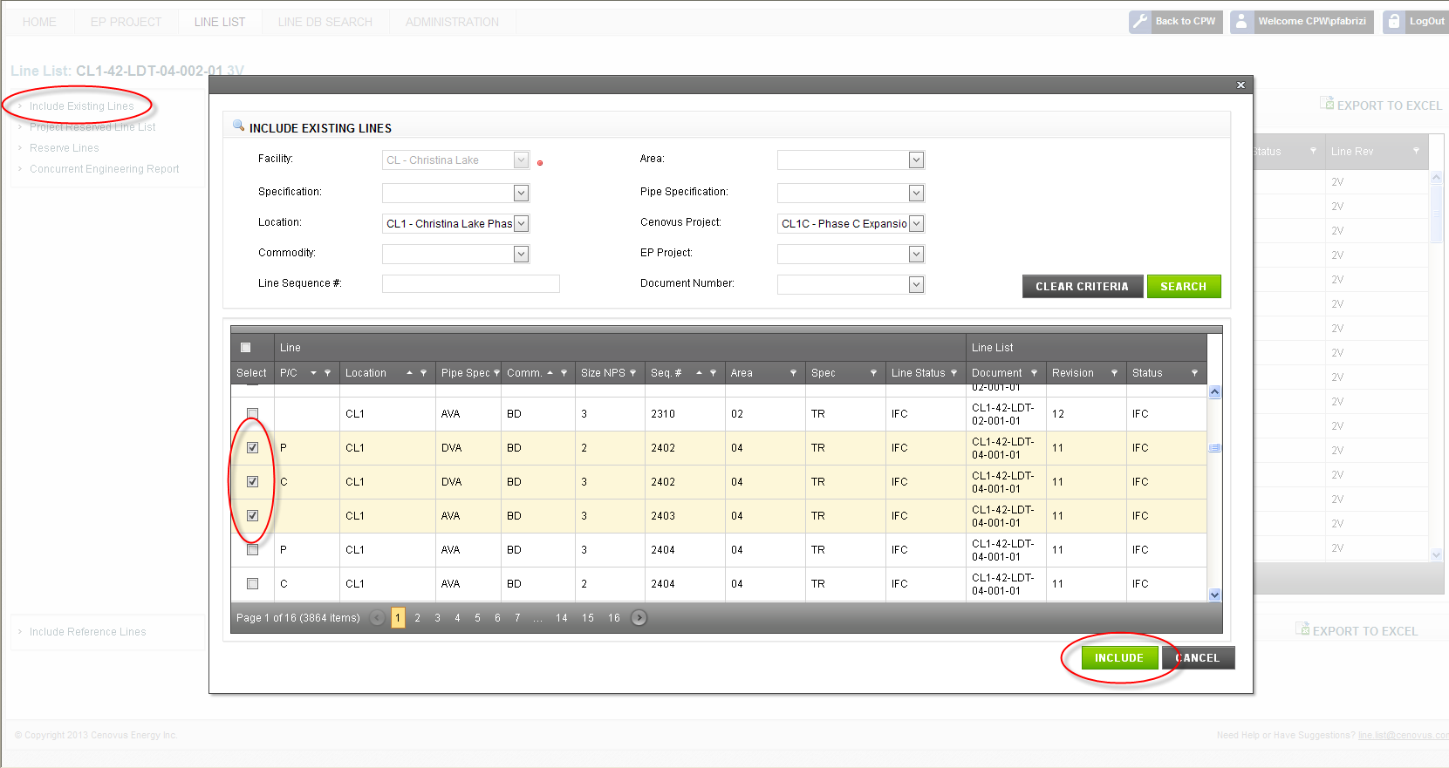

A new revision is created for each of the selected Lines and added to the desired Line List.

* + 1. Include Reference Lines

The Include Reference Lines function includes Lines on a Line List that were previously issued on a different Line List. Reference Lines provide information for related Lines or Lines with similar information (for copy / paste functions).

**Note:** Reference Lines do not appear on an LDT. Reference Lines cannot be changed.

EP Lead Engineers, EP Data Entry and EP Reserve Lines roles for an Project have security permissions to perform this function. Cenovus Administrators can perform this function for any Line List.

This function can only be performed under the following conditions:

* Line List is in a Draft state
* Line List is not locked
* To include reference lines

1. Conduct a search. See the Line List Search section of this document.
2. Click **Lines** actionfor the desired Line List.

The list of Lines for the Line List is displayed.

1. Click **Include Reference Lines**.

A list of Lines meeting the following criteria is displayed:

* Line belongs to the same Facility
* Line has been issued for a hard revision, e.g. IFC
* Line is active

1. Select Lines to include.
2. Click **Include**.

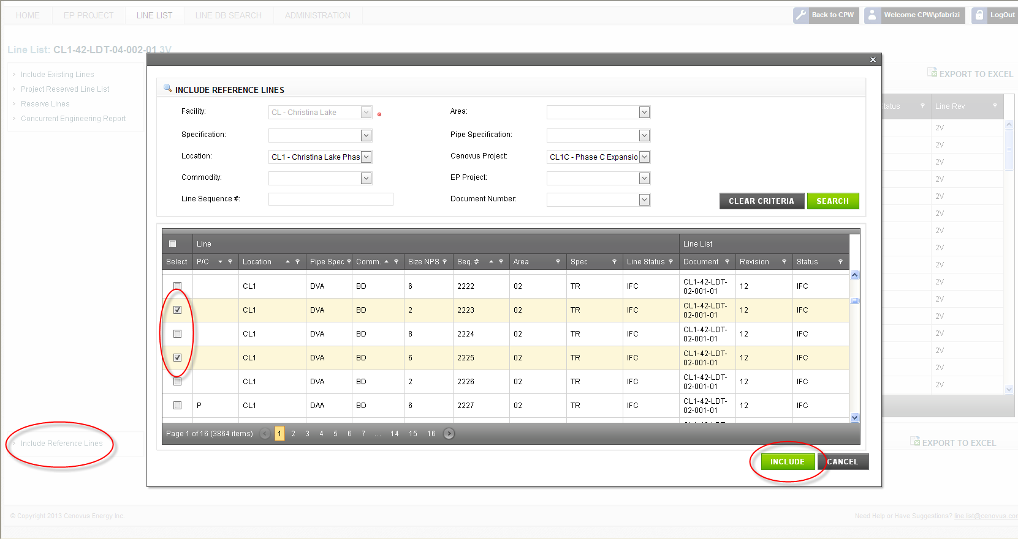

A read-only copy of the Line is added to the Reference Lines section of the desired Line List.

* + 1. Check Out Lines

The Check Out Lines function locks one or more Lines on a Line List for your exclusive use. This ensures others cannot make changes to a Line at the same time and overwrite your changes. While the Line is checked out, others can see your latest changes. Many functions require the Line to be checked out, e.g. Copy Line Data, Create a Child Line.

**Note:** Remember to check in a Line when you have finished all your changes.

EP Lead Engineers, EP Data Entry and EP Reserve Lines roles for an Project have security permissions to perform this function. Cenovus Administrators can perform this function for any Line List.

This function can only be performed under the following conditions:

* Line List is in a Draft state
* Line List is not locked
* Line is not already checked out to another user
* To check out lines

1. Conduct a search. See the Line List Search section of this document.
2. Click **Lines** actionfor the desired Line List.

The list of Lines for the Line List is displayed.

1. Select one or more Lines to check out.

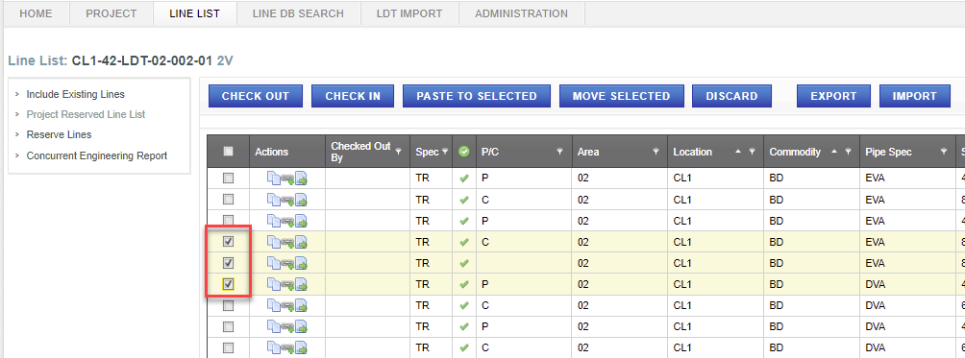

1. Click **Check Out**.

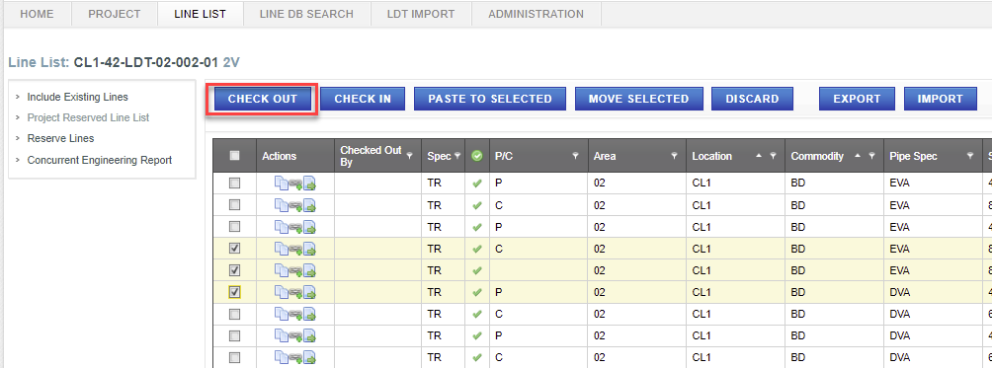

* To check in lines

1. Conduct a search. See the Line List Search section of this document.
2. Click **Lines** actionfor the desired Line List.

The list of Lines for the Line List is displayed.

1. Select one or more Lines to check in.
2. Click **Check In**.

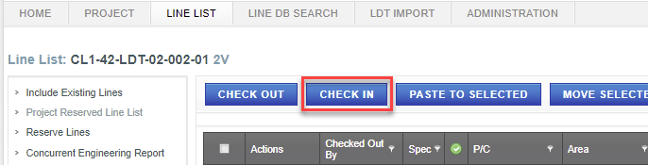

* + 1. Move a Line

The Move a Line function moves a Line from one Line List to another Line List within the same Project.

EP Lead Engineers, EP Data Entry and EP Reserve Lines roles for an Project have security permissions to perform this function. Cenovus Administrators can perform this function for any Line List.

This function can only be performed under the following conditions:

* Line to be moved is checked out to the current user
* Move From Line List is in a Draft state or is the Reserved Line List
* Move To Line List is in a Draft state or is the Reserved Line List
* Move From Line List Revision is not locked or is the Reserved Line List
* Move To Line List Revision is not locked or is the Reserved Line List
* To move lines

1. Conduct a search. See the Line List Search section of this document.
2. Click **Lines** actionfor the desired Line List.

The list of Lines for the Line List is displayed.

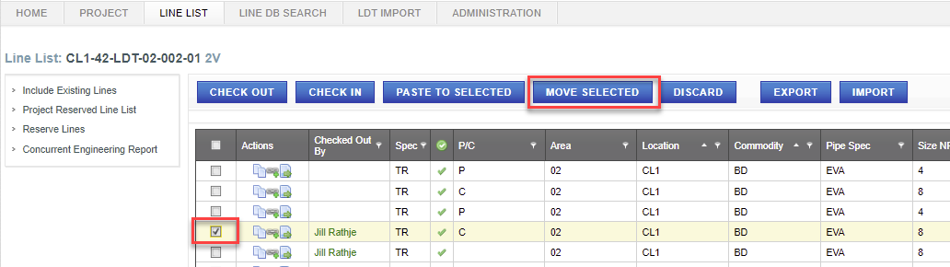

1. Select one or more Lines checked out to you to move.
2. Click **Move Selected**.
3. Select a **To** Line List from the drop-down text box.

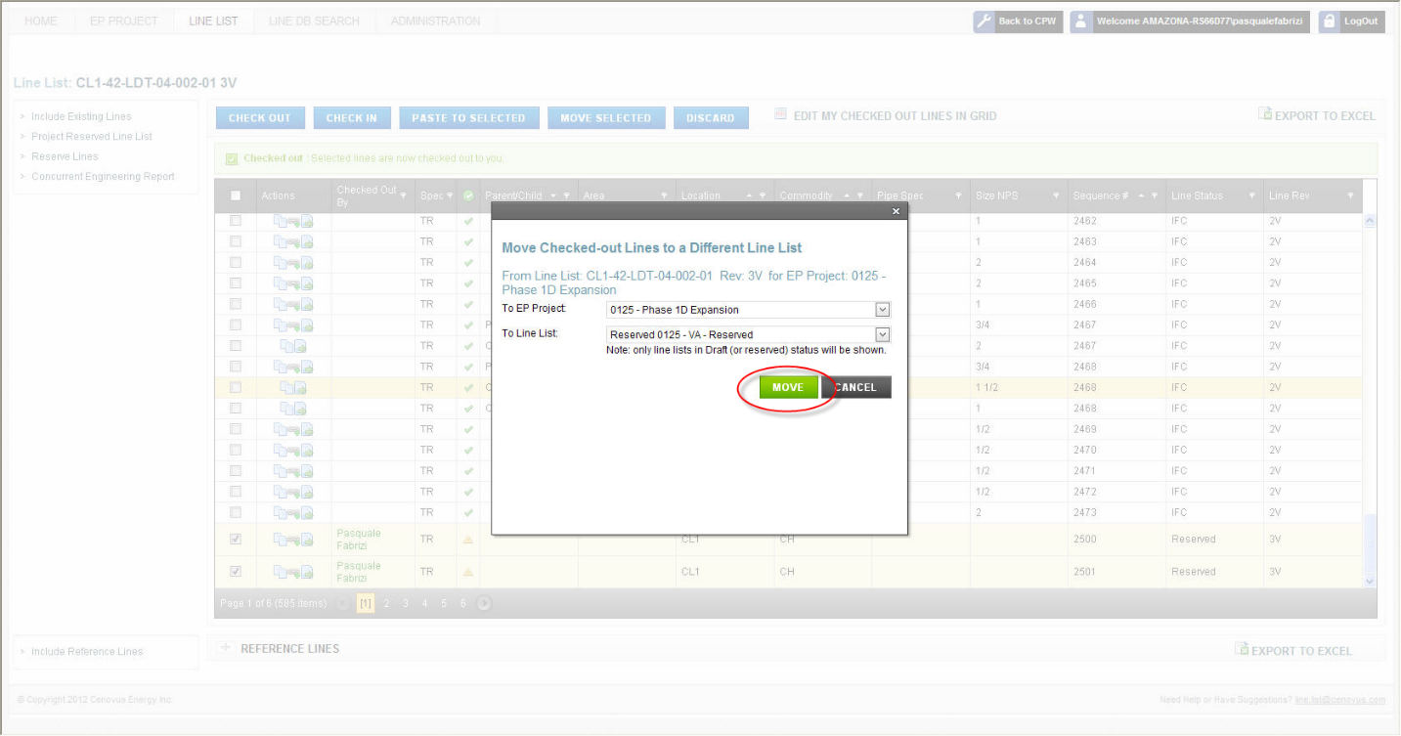

1. Click **Move**.

The desired Line is removed from the **From** Line List and added to the **To** Line List. If a Line is moved to the Reserved Line List, all engineering data is cleared except Location, Commodity, Line Sequence Number and Specification.

* + 1. Copy Line Data

The Copy Line Data copies engineering data from one Line to one or more Lines on the same Line List.

EP Lead Engineers and EP Data Entry roles for an Project have security permissions to perform this function. Cenovus Administrators can perform this function for any Line List.

This function can only be performed under the following conditions:

* Line List is in a Draft state
* Line List is not locked
* Line to copy from may or may not be checked out to the current user
* Line(s) to paste to is checked out to the current user
* To copy line data

1. Conduct a search. See the Line List Search section of this document.
2. Click **Lines** actionfor the desired Line List.

The list of Lines for the Line List is displayed.

1. Click the **Copy** action for the Line with engineering data to copy.

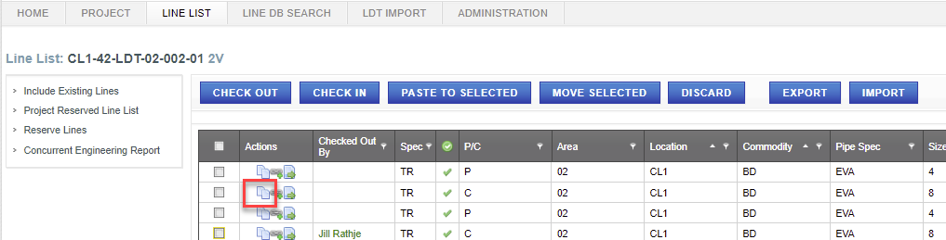

1. Click OK to confirm.

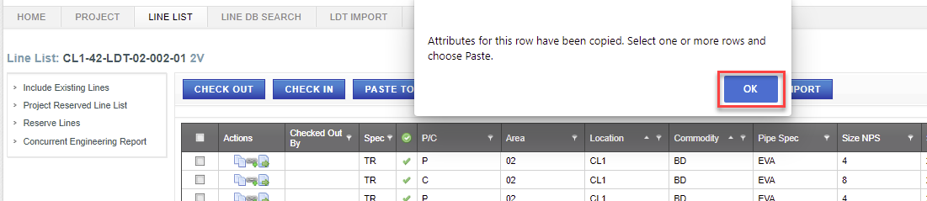

1. Select one or more Lines to paste to.
2. Click **Paste to Selected**.

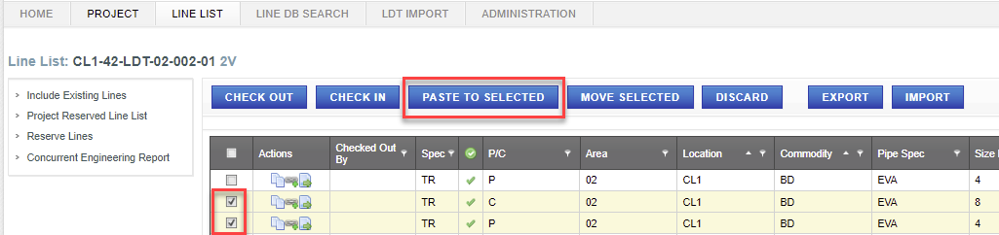

Engineering data is copied to the selected Lines. However, Specification, Area, Location, Commodity, Line Sequence Number, Line Revision, Line Routing From and Routing To are not copied. As well, the corresponding Child Lines for a Parent Line are not copied.

* + 1. Create a Child Line

The Create a Child Line separates a single Line (parent) into multiple Lines (children), each with the same Specification, Location, Commodity and Line Sequence Number.

EP Lead Engineers and EP Data Entry roles for an Project have security permissions to perform this function. Cenovus Administrators can perform this function for any Line List.

This function can only be performed under the following conditions:

* Line List is in a Draft state
* Line List is not locked
* Line is checked out to the current user
* To create a child line

1. Conduct a search. See the Line List Search section of this document.
2. Click **Lines** actionfor the desired Line List.

The list of Lines for the Line List is displayed.

1. Click **Add Child** action for the desired Line (parent or an existing child).

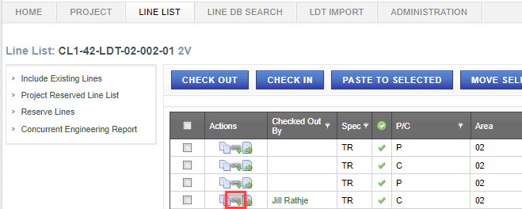

A new Line is created for the Child with the same attributes as the desired Line (parent).

* + 1. Update a Line

The Update a Line function changes the engineering data for a Line. However, Specification, Location, Commodity and Line Sequence Number cannot be changed.

EP Lead Engineers and EP Data Entry roles for a Project have security permissions to perform this function. Cenovus Administrators can perform this function for any Line List.

This function can only be performed under the following conditions:

* Line List is in a Draft state
* Line List is not locked
* Line is checked out to the current user
* To update a line

1. Conduct a search. See the Line List Search section of this document.
2. Click **Lines** actionfor the desired Line List.

The list of Lines for the Line List is displayed.

1. Click **Edit Line** **Details** action for the desired Line.

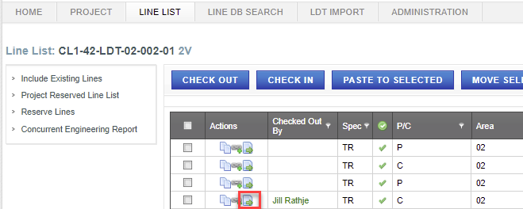

1. Click any one of the tabs.

Engineering data and other information for the desired Line is displayed.

Enter changes to engineering data on any one of the tabs.  
  
**Note:** Engineering data can also be entered using defaults when related engineering data has already been entered. Click **Mechanical Defaults** or **Set All Defaults** on the Details tab, or **Insulation / Tracing Defaults** on the Segments tab.

1. Click **Save** to apply your changes.

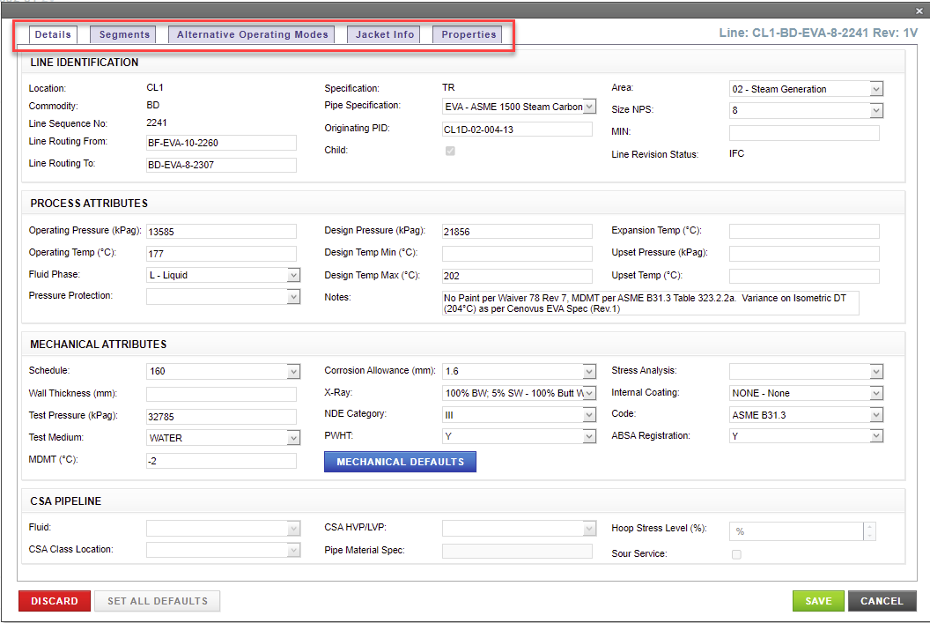

* + 1. Discard a Line

The Discard a Line function removes a Line or group of Lines from a Line List. A Line that was reserved but later determined not required is a candidate for discarding. As well, an existing Line that was mistakenly included on a Line List is also a candidate.

**Note:** Discarding a reserved Line, i.e. a Line that has never been previously issued, not only removes the Line from the Line List, but also the Line List Application. The Line Number can then be reused.

EP Lead Engineers and EP Data Entry roles for a Project have security permissions to perform this function. Cenovus Administrators can perform this function for any Line List.

This function can only be performed under the following conditions:

* Line List is in a Draft state
* Line List is not locked
* Line is checked out to the current user
* Line is Reserved status or Line has never been previously issued on this Line List
* To discard a line

1. Conduct a search. See the Line List Search section of this document.
2. Click **Lines** actionfor the desired Line List.

The list of Lines for the Line List is displayed.

1. Click **Details** action for the desired Line.
2. Click **Discard**.

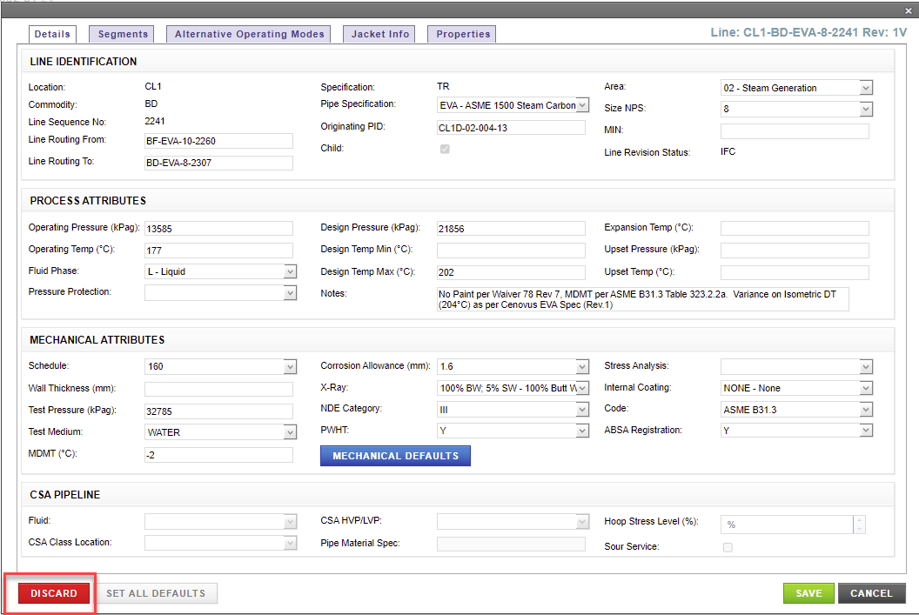

* To discard a group of lines

1. Conduct a search. See the Line List Search section of this document.
2. Click **Lines** actionfor the desired Line List.

The list of Lines for the Line List is displayed.

1. Select one or more Lines to discard.
2. Click **Discard**.

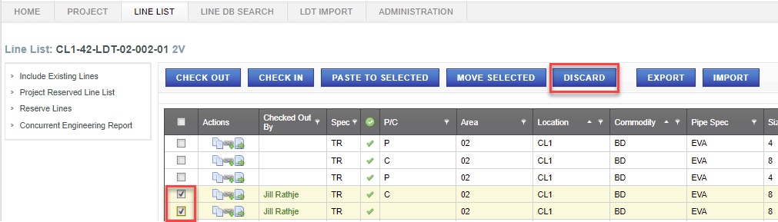

1. Click **Discard** to confirm.

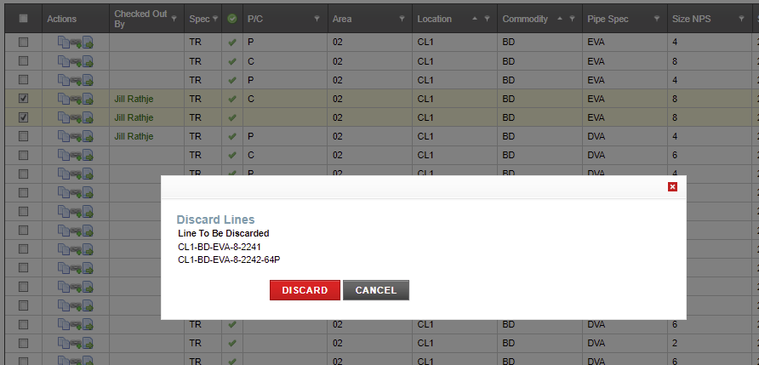

* + 1. Delete a Line

The Delete a Line function marks a Line as deleted. A Line that was previously Issued for Construction (IFC) that will not be physically built is a candidate for deletion. The Line Number is retained and cannot be reused on a new Line.

EP Lead Engineers and EP Data Entry roles for a Project have security permissions to perform this function. Cenovus Administrators can perform this function for any Line List.

This function can only be performed under the following conditions:

* Line List is in a Draft state
* Line List is not locked
* Line is checked out to the current user
* Line is not Reserved status
* Line may or may not have been previously Issued for Construction
* To delete a line

1. Conduct a search. See the Line List Search section of this document.
2. Click **Lines** actionfor the desired Line List.

The list of Lines for the Line List is displayed.

1. Click **Details** action for the desired Line.
2. Click **Delete**.

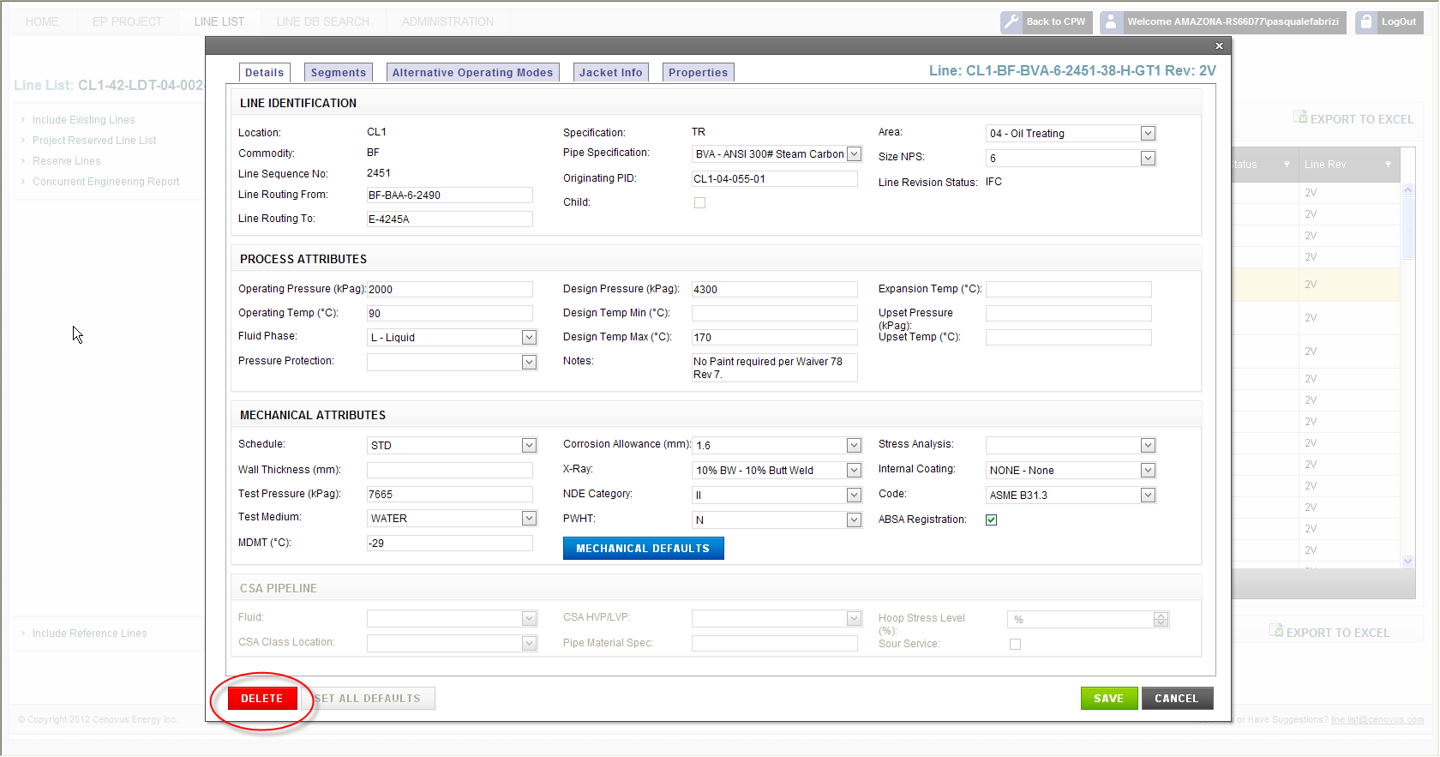

The Line remains on the Line List, but its Status is updated to Deleted. All engineering data is cleared except Location, Commodity, Line Sequence Number and Specification.

* + 1. Grid Export and Grid Import

The Grid Export and Grid Import function provides an Excel-like user interface to edit many Lines at the same time.

EP Lead Engineers and EP Data Entry roles for a Project have security permissions to perform this function. Cenovus Administrators can perform this function for any Line List.

This function can only be performed under the following conditions:

* Line List is in a Draft state
* Line List is not locked
* Lines are checked out to the current user
* To Export lines in grid

1. Create a new Line List or Up rev a Line List to a draft state. See “Add a Line List/ Up Rev a Line List” section of this document; Or conduct a search. See the Line List Search section of this document.
2. Click **Manage Lines for this Line List** actionfor the desired Line List.

The list of Lines for the Line List is displayed.

1. Check Out the lines to be edited. See “Check Out Lines” section of this document.
2. Click **Grid Export.**

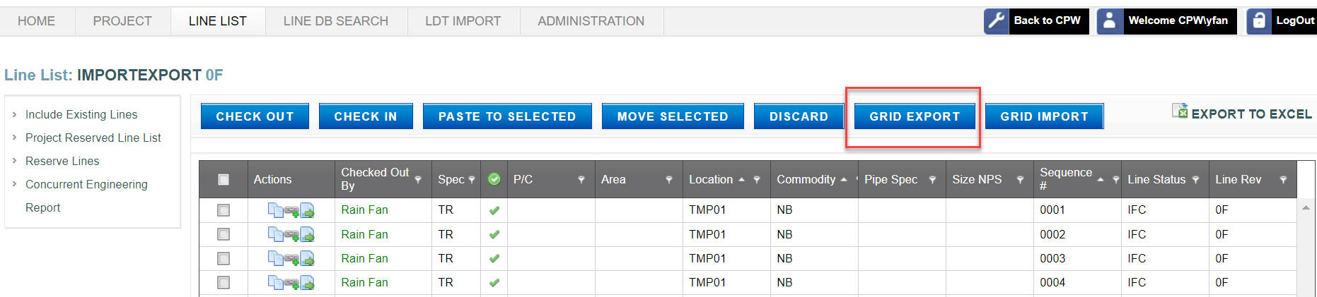

The list of Lines checked out to you is downloaded to a excel file named “export-xxxxxx”.

1. Save a back up copy of the export file before modifying for import (i.e. this back up may be required to undo imported changes).
2. Open the export file and enter changes to engineering data in the spreadsheet with the following important rules:

* Do not delete, sort Lines (rows) or modify any format/field of export file. Doing so will result in data corruption when performing the grid import.
* ALT OP MODE, PARENT CHILD, SPEC, LOC ID, COMM CODE, LINE NO,LINE REV, DOC NUMBER are Read Only fields
* Refer to Section 8 Line List Content and Format of this document for allowable values
* New Lines cannot be reserved / created using this export/import function
* Existing Lines cannot be discarded or deleted, but can be updated
* Child Lines, Segmented Lines, Jacketed Lines and Alternate Operating Modes cannot be created or deleted

Note:

Grid Export will export 500 chars only from “NOTES” column.

Line data can be copied and pasted from an Excel spreadsheet on to the Grid export file to be imported.

* To Import lines in grid

The Grid Import function can only be used with the export file created from the grid Export button. See previous section for rules.

1. Click **Grid Import** to import edited data from the grid export file to the Line List Application.

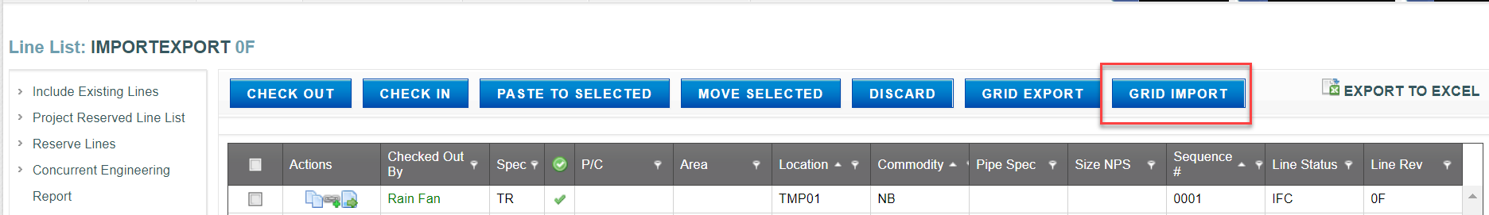

1. Click “Browse” to select your export file.

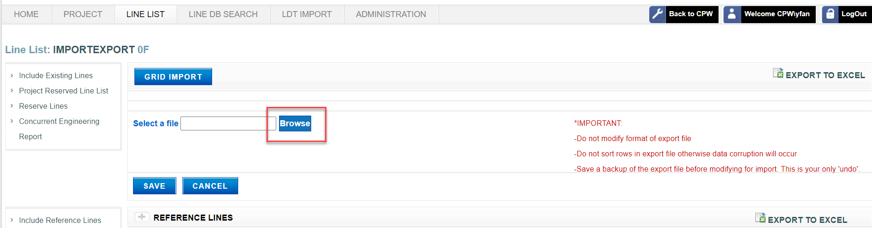

1. Click **Save** to apply your changes. A Validation will be performed to determine if engineering data has been correctly entered and formatted.

* **Record Saved Successfully!** message pops up if valid data is imported with a Green check mark shown on the imported Lines.

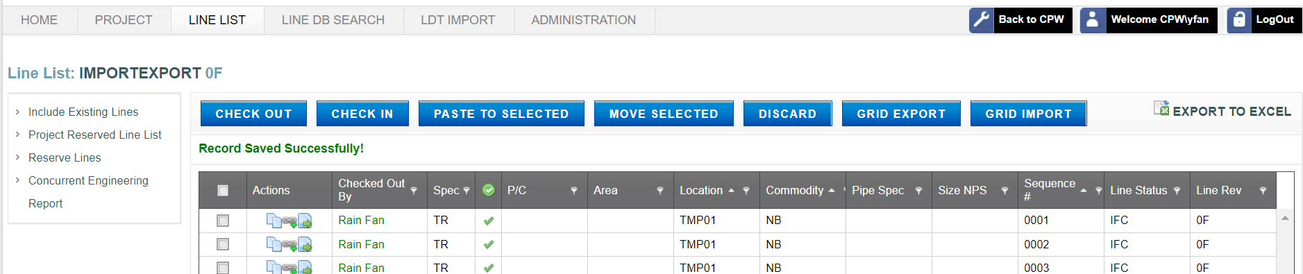

* **Record Saved Successfully!** message pops up if missing data is imported with a yellow Exclamation mark shown on the imported lines.

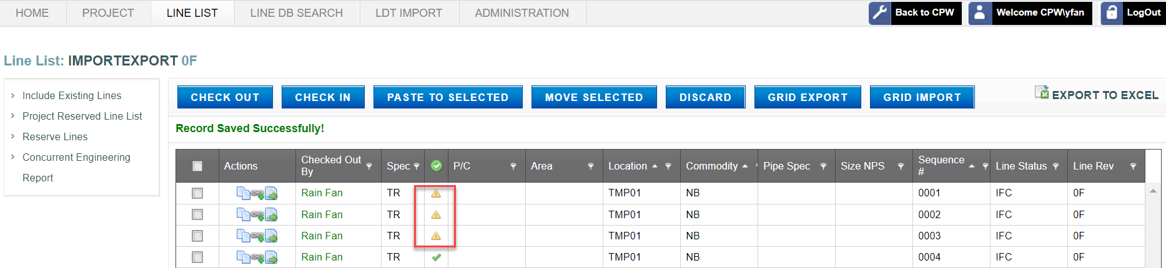

* Error box pops up if invalid data is imported with warning messages. Invalid data must be corrected in order to pass validation and continue with following steps.

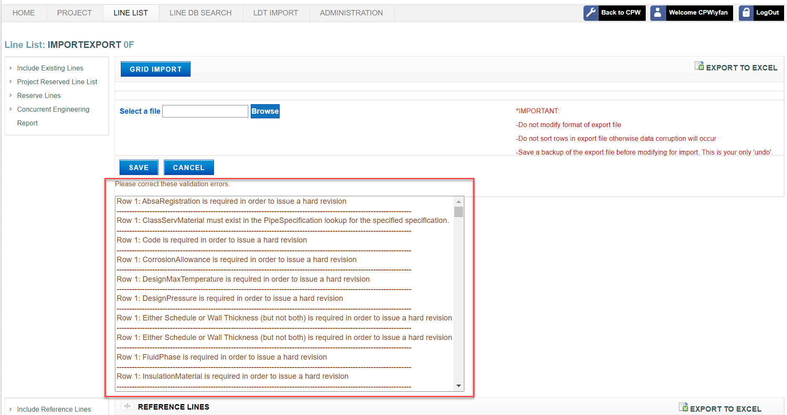

* Missing or required data (for issuing a Hard Revision) is highlighted in yellow triangle with an exclamation mark
* No error will be provided when the grid import file contains updates to Read Only fields. Read Only fields cannot be updated using the grid import file.

**Notes:**

Grid Import will import 500 chars only from “NOTES” column.

“Record Saved Successfully" message does not necessarily mean Data has passed validation process for issuing. An Error box does NOT pop up if the imported lines have missing data only. Users can issue soft revisions of a LDT when there is missing data on imported lines; however, missing or required data must be filled out for issuing a hard revision of an LDT.

Be Patient When clicking GRID EXPORT/GRID IMPORT. Look for the spinning hourglass.

1. Click **Cancel** to discard your changes at this time. Follow the above steps to resume work.

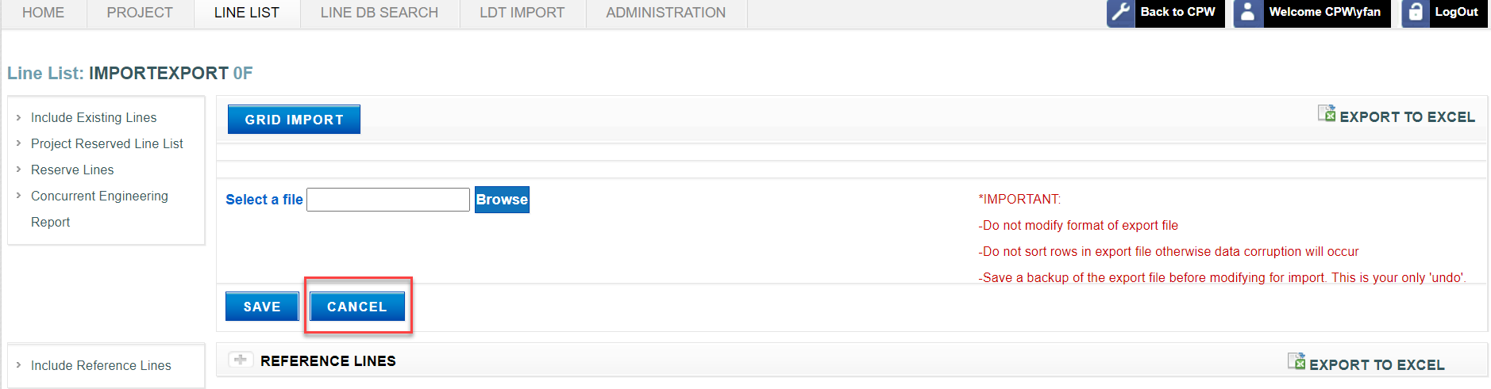

* + 1. Concurrent Engineering

The Concurrent Engineering function views the list of Lines on a Line List that are also active on another Line List.

A Line may appear on many Line Lists at the same point in time. For example, a Line may be engineered, designed and constructed on one Line List. As well, the same Line can be modified as part of an expansion project on a second Line List at the same time as the first Line List, known as concurrent engineering.

EP Lead Engineers and EP Data Entry roles for an Project have security permissions to perform this function. Cenovus Administrators can perform this function for any Line List.

* To view concurrent engineering

1. Conduct a search. See the Line List Search section of this document.
2. Click **Lines** actionfor the desired Line List.

The list of Lines for the Line List is displayed.

1. Click **Concurrent Engineering Report**.

The list of Lines that are active on another Line List is displayed.

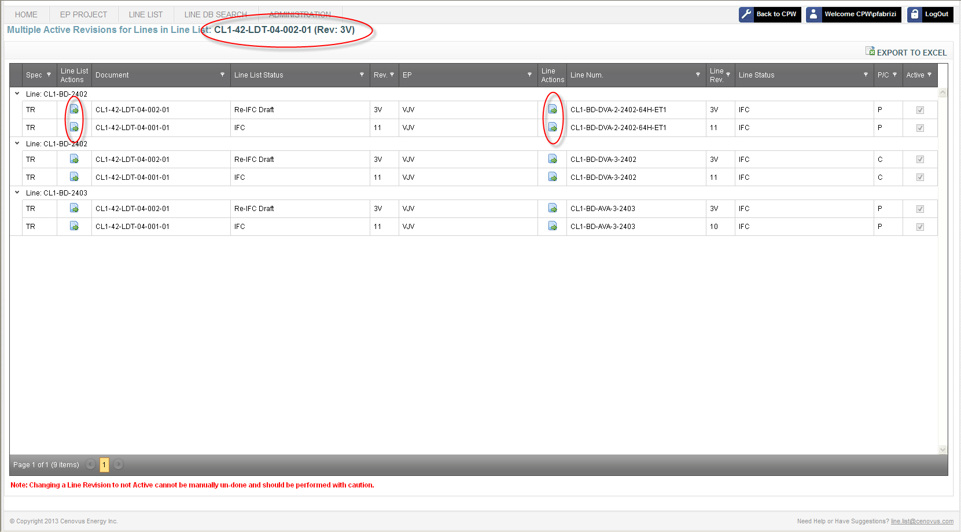

1. Click the Line List **Document Number** hyperlink to navigate to the list of Lines.
2. Click the **Line List Details** action to view more information for the Line List of the desired Line.
3. Click the **Line Details** action to view more information for the desired Line.
4. Line Database Search

The Line Database Search tab allows you to view information for one Line or a group of Lines.

* 1. Search for Lines

The Search for Lines function searches for Lines based on a single modifier or number of modifiers to return more focused results.

All CPW Users and all Line List Application users have security permission to perform this function. However, Security Trimming may hide buttons, functions or information within the application from view.

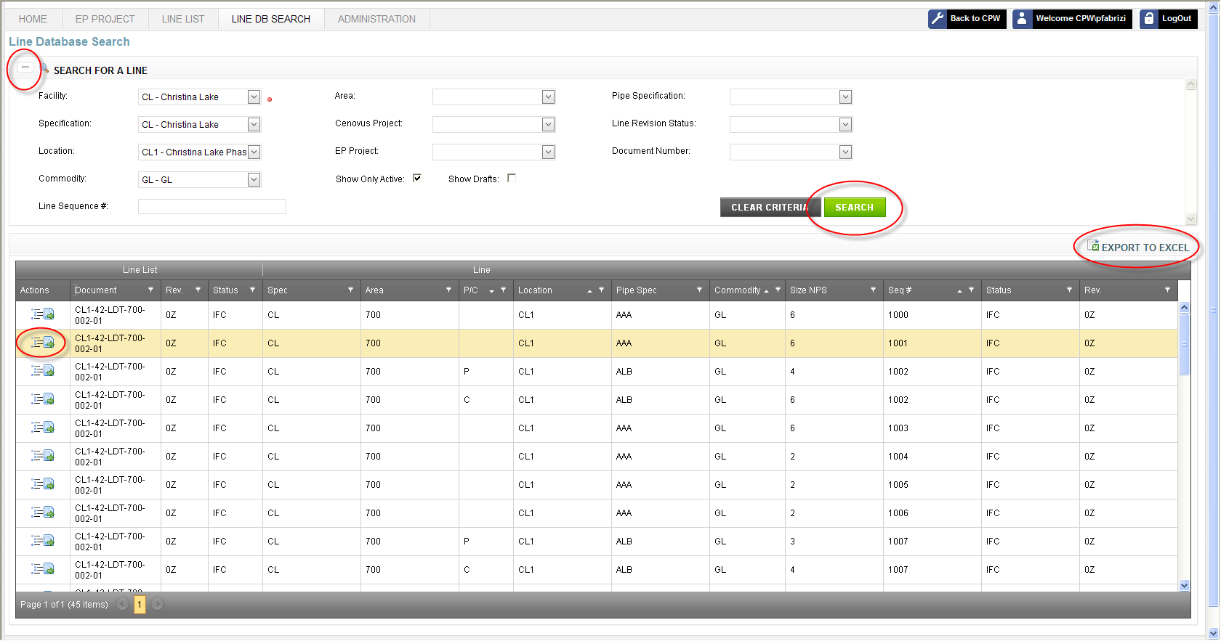

For instance, you can search on the Christina Lake facility and get all Lines related to that facility; but that would be enormous and system exhaustive. Narrowing down your search by adding more parameters brings better results while still allowing for great flexibility. You can use information like Location, Commodity or Line Sequence Number to return more focused results.

* To conduct a search

1. Click the **Line DB Search** navigation tab.
2. Select your search criteria from the drop-down text boxes.

Note: Drop-down text boxes are automatically filtered based on search criteria already specified, e.g. after selecting Christina Lake facility, only locations within Christina Lake can be selected. As well, auto-complete offers suggestions as you type.

1. If you want to search for all revisions of a Line, de-select **Show Only Active** checkbox.
2. If you want to search for revisions of a Line that are still in a Draft state and have not yet been Issued, select **Show Drafts** checkbox.
3. Click **Search**.

The results display for your search combination.

If your search is successful, information will display; otherwise, the results area will remain empty. The Search Results area displays the number of lines (records) that meet your search criteria.

1. See the Sorting and Filtering Results section of this document for additional capabilities.

Note: You can show or hide your search criteria by clicking **+/- Search Panel**.

* 1. Export Lines

The Export Lines function saves your search results in a Microsoft Excel spreadsheet.

All CPW Users and all Line List Application users have security permission to perform this function. However, Security Trimming may hide buttons, functions or information within the application from view.

* To export to a spreadsheet

1. Conduct a search. See the Line Database Search section of this document.
2. Click **Export to Excel** to open a Microsoft Excel spreadsheet populated with your full search results.
3. Review and assess the information.

**Note**: You cannot export an empty search. Data needs to be present.

* 1. Navigate to Line List

The Navigate to Line List function views the entire Line List for a Line.

All CPW Users and all Line List Application users have security permission to perform this function. However, Security Trimming may hide buttons, functions or information within the application from view.

* To navigate to the Line List

1. Conduct a search. See the Line Database Search section of this document.
2. Click **View Line List Lines** action for the desired Line.

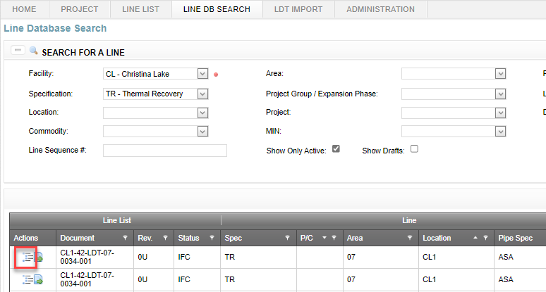

The Line List for the desired Line is displayed, including all other Lines on the Line List.

**Note**: Refer to the Line Lists section of this document for a description of functions for Line Lists including Print an LDT (Line Designation Table).

* 1. Line Details

The Line Details function allows you to view more information for a Line.

All CPW Users and all Line List Application users have security permission to perform this function. However, Security Trimming may hide buttons, functions or information within the application from view.

* To view Line details

1. Conduct a search. See the Line Database Search section of this document.
2. Click **Line Details** for the desired Line.

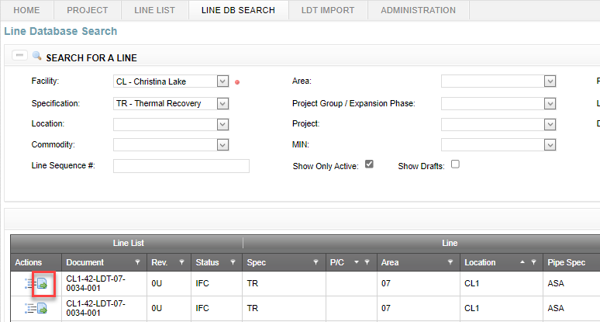

1. Click any one of the tabs.

Engineering data and other information for the desired Line is displayed.

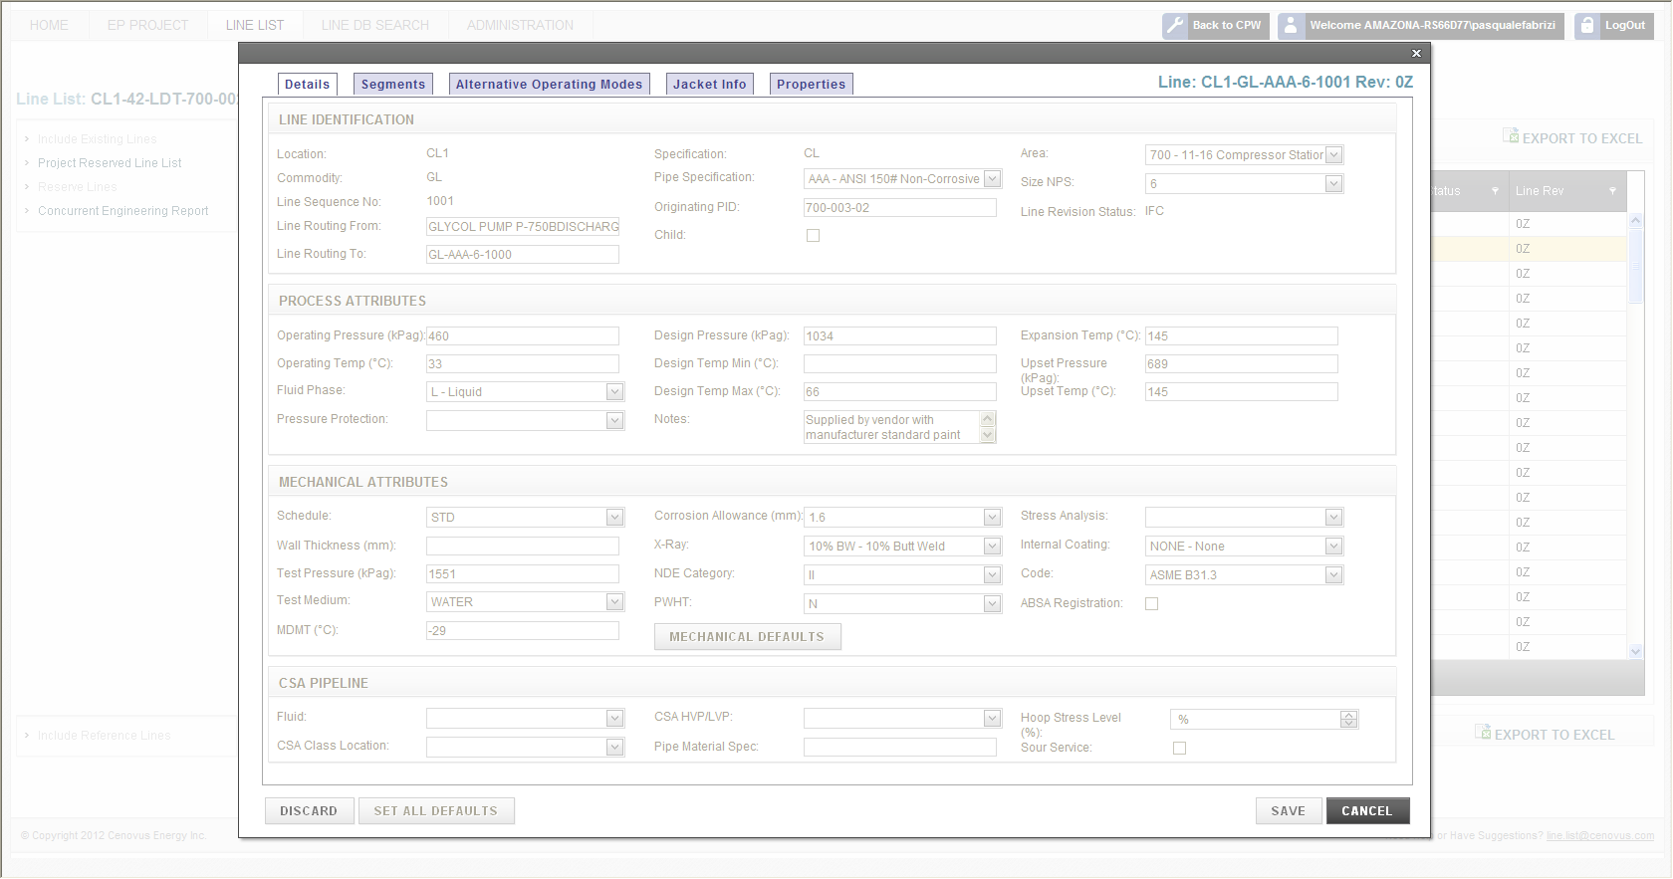

1. Line List Content and Format

This section presents the contents (i.e. column headings) of a line list.

* 1. Acceptable Line List Field Attributes

In the Line List application, when clicking on **Edit Line** **Details** action for a desired line in a line list, data can be entered in three different ways:

* Drop down menu: allows you to choose from a list of acceptable values
* Combination of drop down menu and manual input: allows you to choose from a list of acceptable values or, if the value you want is not listed, allows you to manually enter the data
* Manual input only

When editing lines in an grid export file, data can only be entered manually; however the data entry must follow the acceptable values provided. Appendix 1 lists the acceptable values for each column heading in a line designation table. If you require a value that has not been included in the list, send a request to update the list to [line.list@cenovus.com](mailto:line.list@cenovus.com)

* 1. Alternate Operating Mode

An alternate operating mode allows the specification of different parameters for additional operating modes to ensure that line design conditions represent the full operating exposure and that material selection, stress analysis and testing consider all modes of operation. Alternate operating modes may be used are for lines in cyclic service; i.e. lines which see normal operation and have an alternate mode with a different fluid at different operating conditions (i.e. regeneration gas). This mode may also be used to indicate different conditions and requirements for lines which have different service fluids based on the SAGD mode (i.e. wellhead piping connected to spool pieces which may see steam or produced emulsion for steam circulation and production modes respectively). Lines should be tagged with the commodity which will be flowing in the line for the longest life-cycle duration. For example if steam is flowing in reverse direction through the producer wellhead piping during steam circulation but after conversion the piping will carry produced emulsion the line shall carry a “PE” designation not an “HS” designation. Similarly a line carrying produced gas for its service mode and hot fuel gas for its regeneration mode would be labeled as “PG” not “FG”.

Attributes which may be input for the alternate operating mode are:

* Line Routing From (these may be reversed or attached to a temporary spool)
* Line Routing To (may be reversed or attached to a temporary spool)
* Operating Pressure
* Operating Temperature
* ABSA Registration
* Code
* Notes

Additional fields allowed for CSA pipelines

* Fluid
* Sour Service

The upset pressure and temperature for stress calcs and expansion temperature on the main line shall consider the worst case based on the primary service (main line) and alternate operating modes. Pipe material specifications such as pipe material, schedule or wall thickness, insulation type and thickness and NDE are constant and are specified on the main line.

* 1. Specification

All new lines are required to conform to the current TR specification. Foster Creek has two specifications: one for the legacy Foster Creek lines (FC) and one for TR Specification (TR). Christina Lake also has two specifications: one for the legacy Christina Lake lines (CL) and one for TR Specification (TR). The breakdown of FC, CL, and TR spec is outlined on the Notes drawing (Appendix 2).

Projects adopting the TR spec are:

* Foster Creek Offsites: 2008 (Brackish Water and Disposal Pads only), 2009 and later
* Foster Creek Commercial Facility: Phases F/G/H and MOC/Specialty Projects 2008 and later
* Christina Lake Offsites: 2008 and later
* Christina Lake Commercial Plant: Phase 1C-H and MOC/Specialty Projects 2008 and later
* Telephone Lake: all commercial and offsites projects
* Narrows Lake: all commercial and offsites projects
  1. Parent/Child Lines

A parent/child relationship was created for lines which have multiple sizes. A separate line entry is required for the child line to allow specification of different engineering parameters for the change in line size, i.e. the line may have different pipe wall thickness, different insulation thickness, etc. Any additional rows for the same line number must input a “C” in the PARENT/CHILD column to indicate a child relationship. This identifies that the line number is not a duplicate and that the line is related to the first row entry which should be identified as a parent (“P”). It is not critical which line size is assigned as the parent but typically it should be the dominant line; having the longest relative length. If the line starts as 6” but swages down to 4” and is 4” for most of its length the parent line should be 4”.

All primary lines shall be designated with a “P” for parent even if there are no secondary children rows present.

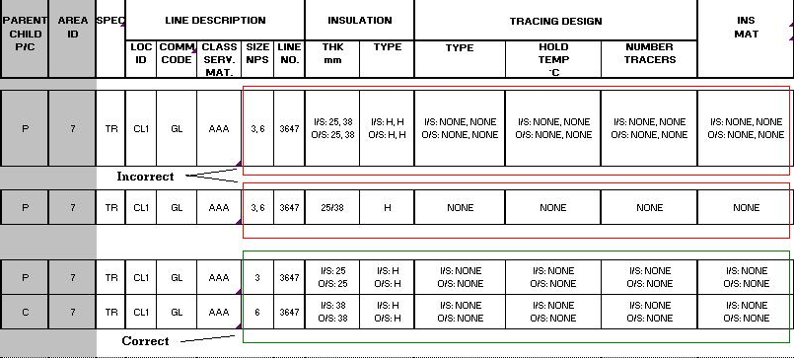

* 1. Area Identifier

The area identifier represents the plant area. This field is not part of the uniqueness of the line number but is a required data field to allow filtering and line searches in the Line List Application. In expansion phases line lists may be built and issued by area. This typically reflects the engineering work subdivision and allows area leads to be responsible for work under their supervision.

* 1. Location Identifier

Foster Creek uses the location identifier or lack of one to designate the spec used for lines in the Foster Creek 1A-E Commercial Plant. Foster Creek Plant lines prefixed by “FC1-“ follow the TR specification. Foster Creek lines prefixed by “FCX-“ or without a location identifier prefix are legacy FC lines and follow the Legacy FC specification.

All Christina Lake lines are prefixed by the location identifier “CL1-“ unless the line is located at an offsite with a designated TR offsite location identifier. For legacy lines with no TR offsite location identifier the lines default to a “CL1-“ prefix. The 11-16 compressor station and the 15-35 disposal pad do not have TR offsites prefix and maintain a “CL1-“ prefix. For these legacy lines, 700 and 15-35 are the respective areas to assist in identifying the lines.

For Location (Plant and Wellpad) Identifiers, refer to [CVE-10-STD-00-0007-001](https://cpw.cenovus.com/projects/EIM/Governing%20Documents/CVE-10-STD-00-0007-001%20Reference%20and%20Common%20Data.pdf) Reference and Common Data.

Note: Wellpad lines have to be reserved under an pad-specific identifier.

* 1. Commodity Code

The commodity code is a two character abbreviation for the fluid service. Available TR commodities are provided in CVE-10-STD-00-0007-001 Reference and Common Data.

* 1. Pipe Specification (Class/Service/Material)

The TR piping spec is a typically a three character designation based on class, service, and material. A pipe class modifier may follow the typical three character designation if necessary. Refer to TR-44-SPC-00-001-01 Piping Material Classes for pipe specifications.

* 1. Size NPS

This is the nominal pipe size in inches.

* 1. Line Number

The line sequence number is a 4 digit number.

* 1. Insulation Thickness

This is the insulation thickness in mm. Enter the number only not the units, i.e. 25 not 25 mm. Refer to TR-43-SPC-00-021-02 Insulation specification for insulation thickness tables.

* 1. Insulation Type

Refer to TR-43-SPC-00-021-02 Insulation specification for insulation types.

* 1. Tracing Design Type

Refer to TR-43-SPC-00-026-01 Glycol Heat Tracing and TR-46-SPC-00-031-01 Electrical Heat Tracing for tracing design type.

* 1. Tracing Hold Temperature

Refer to TR-43-SPC-00-021-02 Insulation Specification for tracing hold temperatures.

* 1. Number of Tracers

Enter number of tracers followed by "B" for bare or "C" for heat transfer cement. For example "1B" = 1 bare tracer, "1C" = 1 tracer with heat transfer cement. The number of tracers and bare and heat transfer cement requirements are detailed in TR-43-SPC-00-021-02 Insulation (Appendix A: Insulation Thickness Tables).

* 1. Insulation Material

Enter an insulation material abbreviation or enter None. Refer to TR-43-SPC-00-021-02 Insulation.

* 1. Pipe Segment Format to Define Insulation

For a pipe that has both inside and outside (and potentially underground) segments, adopt the following formatting for insulation and tracing fields:

I/S: XXX <alt enter>

O/S: XXX <alt enter>

U/G: XXX

Pipe segments are preferred to be included in the following order: inside (I/S), outside (O/S), underground (U/G) for the upload macro to process the data. The number of spaces between the colon and XXX does not matter, nor does the number of spaces after XXX.

If a line does not require one of segments above, then delete that segment from the cell. For example, if a line does not have an inside segment enter:

O/S: XXX <alt enter>

U/G: XXX

If a line has no tracing or insulation for one of the segments, use the word NONE. For example, if a line runs both inside and outside but has no insulation for the inside segment, type the following into the cell:

I/S: NONE <alt enter>

O/S: XXX

If a line has more than one type of insulation or tracing for a segment type, then further indicate sub-segments with numbers as follows:

O/S(1):GT1

O/S(2): ET1

If a line is split into segments (i.e. it has a combination of inside, outside, underground portions) then these conditions must be placed in a consistent position in each field.

Enter information as follows:

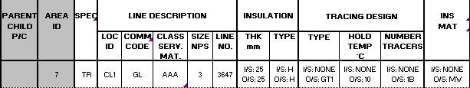

* 1. Line Routing From/To

Enter the equipment or line located immediately upstream or downstream of the line. Do not include multiple entries. Parent/Child lines may have same Line Routing From/To entries.

* 1. Originating P&ID

Enter only the P&ID that the line originates on. Do not enter all of the P&IDs that the line appears on. For the P&ID attribute, enter only the first 3 digits and the last 9 digits of the P&ID, example FC1-42-PID-06-0023-001 should be entered as FC1-06-0023-001.

* 1. Schedule/Wall Thickness

Enter one number, either schedule or wall thickness (in mm not inches) and enter only the number. Do not enter SCH or mm. Do not fill out both columns. For example, enter 80 not SCH 80 or 10.97 not 10.97 mm.

* 1. Fluid Phase (V/L/M)

Enter V for vapor phase, L for liquid phase or M for mixed phase.

* 1. Operating Pressure (kPag)

For a line with two services with different operating pressures enter an additional row and specify the second row as an alternate operating mode. Enter only the unique information for the alternate operating mode.

For a hot oil jacketed line include the pressure and temperature of both the pipe and the annulus. Show the Pipe temperature or pressure on the top line and use the Alt-Enter command to enter the Jacket temperature or pressure on the second line within the same row (cell). Enter the data for the Jacket side as (JK: XXX).

* 1. Operating Temperature (°C)

For a line with two services with different operating temperatures enter an additional row and specify the second row as an alternate operating mode. Enter only the unique information for the alternate operating mode.

For hot oil jacketed lines include the pressure and temperature of both the pipe and the annulus. Show the Pipe temperature or pressure on the top line and use the Alt-Enter command to enter the Jacket temperature or pressure on the second line within the same row (cell). Enter the data for the Jacket side as (JK: XXX).

* 1. Design Pressure (kPag)

Enter the mechanical design pressure. For a hot oil jacketed line include the mechanical design pressure of both the inner pipe and the annulus. Show the Pipe design pressure on the top line and use the Alt-Enter command to enter the Jacket design pressure on the second line within the same row (cell). Enter the data for the Jacket side as (JK: XXX).

* 1. Design Temperature Max (°C)

Enter the mechanical design temperature. For a hot oil jacketed line include the mechanical design temperature of both the inner pipe and the annulus. Show the Pipe design temperature on the top line and use the Alt-Enter command to enter the Jacket design temperature on the second line within the same row (cell). Enter the data for the Jacket side as (JK: XXX).

* 1. Design Temperature Min (°C)

Enter the minimum design temperature. This is the minimum temperature design for pressurized service and may be required based on low ambient or upset conditions. The minimum design temperature is assigned by the Process engineer based on analysis of the process system. This value should be greater than or equal to the minimum design metal temperature or an alternate material or warm-up pressurizing procedures should be considered.

* 1. Test Pressure (kPag)

Refer to Note 7 in the TR Notes drawing (Appendix 2).

For hot oil jacketed lines include the test pressure of both the pipe and the annulus. Show the pipe test pressure on the top line and use the Alt-Enter command to enter the Jacket test pressure on the second line within the same row (cell). Enter the data for the Jacket side as (JK: XXX).

* 1. Test Medium

Enter "Water", "Air" or "N/A".

* 1. Jacketed Lines

Fields which apply to both the inner pipe and the annulus should include the specification for both services in the same cell. Show the primary service pipe data on the top line and use the Alt- Enter command to enter the Jacket data on the second line within the same row (cell). Enter the data for the Jacket side as (JK: XXX).

The following example illustrates the convention for jacketed piping:

|  |  |  |  |  |  |  |  |  |  |  |  |  |  |  |  |  |
| --- | --- | --- | --- | --- | --- | --- | --- | --- | --- | --- | --- | --- | --- | --- | --- | --- |
| **LINE DESCRIPTION** | | | | | **SCH/ WALL THK mm** | **OPERATING** | | **DESIGN** | | | **TEST** | | **MDMT TEMP (3)**  **°C** | **CORR ALLOW**  **mm** | **X-RAY** | **NDE CAT (6)** |
| **LOC**  **ID** | **COMM**  **CODE** | **CLASS**  **SERV. MAT.** | **SIZE**  **NPS** | **LINE**  **NO.** | **PRESS**  **kPag** | **TEMP**  **°C** | **PRESS**  **kPag** | **TEMP (°C)** | | **PRESS**  **kPag**  **(7)** | **MEDIUM** |
| **MAX** | **MIN** |
| FC1 | SU | AMA | 2 (JK: 3) | 3647 | 80 (JK: 40) | 47 (JK: 700) | 182 (JK: 149) | 103 (JK: 1379) | 343 (JK:179) | -29 | N/A (JK: 2950) | N/A (JK:WATER) | -29 | 3.2 (JK:1.6) | 100% BW (JK:10%BW) | III (JK:II) |

* 1. EXP Temperature (°C)

Expansion temperature is the maximum pipe temperature resulting from abnormal operating conditions such as upsets, steam-out, steam tracing or regeneration. If no temperature is shown, the design temp will be taken as the expansion temp. Refer to Note 1 in the TR Notes drawing (Appendix 2).

* 1. Upset Pressure/Temperature (kPag/°C)

Upset pressure and upset temperature are used for stress calculations - show the worst case conditions of coincident pressure and temperature. Do not copy and paste the values from the design pressure & design temperature columns. If the values are the same as those in the design pressure & design temperature columns, then leave these cells blank. Refer to Note 2 in the TR Notes drawing (Appendix 2).

* 1. MDMT

Enter the minimum design metal temperature (at design pressure). Refer to Note 3 in the TR Notes drawing (Appendix 2). Refer to Table A1 and section 323.2.2 of ASME B31.3 for MDMT values. This number is calculated based on limitations of the material (material composition and thickness) at the design pressure.

* 1. Corrosion Allowance

Enter the corrosion allowance in mm required for the service as per the pipe specification.

* 1. X-RAY

Enter one or more of the following, depending on line requirements:

100% BW

15% BW

10% BW

5% SW

Where BW is butt weld and SW is socket weld. For a line with both BW and SW indicate % radiography for both. Enter each % requirement on a separate line in the same row, use the Alt- Enter command to add another line within the cell.

* 1. NDE CAT

Enter the NDE Category as per TR-44-SPC-00-001-01 Piping Material Classes.

The NDE (Non-Destructive Examination) category indicates the requirements for NDE other than radiography i.e. magnetic particle inspection, liquid penetrant inspection and hardness testing.

* 1. PWHT

Post Weld Heat Treatment: refer to TR-44-SPC-00-001-01 Piping Material Classes.

Enter Y or N.

* 1. Analysis

Analysis column to be completed by the Stress Engineer based on Cenovus Specification TR-44-SPC-00-012-01 Piping Flexibility and Supports using the following:

C = CRITICAL LINE

This indicates a critical line that will require stress engineering performed by computer analysis.

M = MANUAL INSPECTION

This indicates a line that will require stress engineering performed by manual or hand calculation.

V = VISUAL

This indicates the possibility of a stress review by visual inspection.

* 1. Painting System

Enter the Painting System ID if painting is required. Otherwise enter NONE. See TR-43-SPC-00-019-01 External Coating and Galvanizing.

* 1. Internal Coating/Liner Specification

Enter type of internal liner if applicable or enter NONE.

* 1. Code

Enter B31.1, B31.3, CSA Z662-03, CSA Z662-03 variance, etc.

* 1. ABSA Registration

Enter Y or N.

* 1. Pressure Protection PSV/OPPSD

Enter PSV or OPPSD to indicate the type of overpressure protection.

* 1. As-Built Status

Enter:

As Built - Service,

As Built - Demolished, or

As Built – Abandoned,

to positively indicate that the line was as-built.

* 1. Notes

General Notes are applied as per the applicable specification Notes drawing page (Appendix 2). ONLY Notes 1 to 8 (per the TR-Notes drawing) can be referenced in this cell for TR lines. NO new note numbers will be assigned. Additional "Notes" for the line must be typed into the notes cell. "Note Legends" will NOT be accepted.

* 1. Line Revision Number

The line revision number is assigned automatically by the application. It is the revision of the document in which the last line revision changes were made. For example if a line was last modified in an LDT at Rev. 3V. The line revision would remain at 3V even if the LDT document revision is higher.

* 1. CSA Pipelines

Additional columns are required to be filled out if CSA Z662 (VAR.) is selected:

|  |  |  |  |  |  |
| --- | --- | --- | --- | --- | --- |
| FLUID | CSA CLASS LOCATION | CSA HVP/LVP | PIPE MATERIAL SPECIFICATIONS | HOOP STRESS  LEVEL  % | SOUR SERVICE (Y/N) |

Appendix 1: Acceptable LDT Values for Line List Application

|  |  |  |  |
| --- | --- | --- | --- |
| **COLUMN HEADINGS** | **ACCEPTABLE VALUES** | **DESCRIPTION** | **REFERENCE** |
| Alternate Operating Mode | Y  N |  |  |
| Parent / Child | P C |  |  |
| Area ID | Valid Area IDs are outlined in the Reference and Common Data governing document. These are of a numeric format and shall include the leading zeros where applicable.  Example:  Foster Creek Phase 3 02 03 04  Christina Lake 1A/B 100  200 300 700  Christina Lake 1C-H 01 02 03 04 | Description as per Area IDs outlined in design and drafting spec.  Steam Generation Oil Treating Hydrocarbon Tankage & VRU  Water Treatment and Steam Generation Steam Injection and Production Production Facilities 11-16 Compressor Station   Water Treatment  Steam Generation  Steam Generation  Oil Treating | CVE-10-STD-00-0007-001 Reference and Common Data |
|
|
|
|
|
|
|
|
|
|
|
|
|
| Specification | CL   FC   TR | PanCanadian or ORBU spec used in CL Phase 1A/B  FC legacy spec  New thermal recovery spec (shall be used for all new lines) |  |
|
|
|
| Location ID | Refer to STD |  | CVE-10-STD-00-0007-001 Reference and Common Data |
|
| Commodity Code | Refer to STD |  | CVE-10-STD-00-0007-001 Reference and Common Data |
|
| Class Service Material | Refer to TR Spec |  | TR-44-SPC-00-001-01 Piping Material Classes |
|

|  |  |  |  |
| --- | --- | --- | --- |
| **COLUMN HEADINGS** | **ACCEPTABLE VALUES** | **DESCRIPTION** | **REFERENCE** |
| Size NPS | 1/4 3/8 1/2 3/4 1 1 1/4 1 1/2 2 2 1/2 3 4 5 6 8 10 12 14 16 18 20 24 30 32 36 |  |  |
|
|
|
|
|
|
|
|
|
|
|
|
| Line Sequence No. | Numeric value (integer 4 digits) | Generated by reserving lines in Line List Application. |  |
| Insulation Thickness, mm | 25 38 51 64 76 89 102 156 NONE  5  10  15  20  30  40 |  | TR-43-SPC-00-021-02 Insulation  (Note: 5,10,15,20,30,40 are only applicable for Aerogel) |
|
|
|
|
| Insulation Type | C CP H P NONE | Cold Insulation  Condensation Protection  Hot/Freeze Protection  Personnel Protection | TR-43-SPC-00-021-02 Insulation |
|
|

|  |  |  |  |
| --- | --- | --- | --- |
| **COLUMN HEADINGS** | **ACCEPTABLE VALUES** | **DESCRIPTION** | **REFERENCE** |
| Tracing Type | ET1   ET2   ET3   GT1  GT2  GT3   GT3-70 GT3-80 JGL NONE | Electric Traced Freeze Protection (Hold 10°C)  Electric Traced Viscosity Control (Hold 45°C)  Electric Traced Viscosity Control (Hold Temp to be Specified)  Glycol Traced Freeze Protection (Hold 10°C)  Glycol Traced Viscosity Control (Hold 45°C)  Glycol Traced Viscosity Control (Hold Temp to be Specified)   Glycol Traced (Hold 70°C) Glycol Traced (Hold 80°C) Jacketed Glycol | TR-43-SPC-00-026-01 Glycol Heat Tracing TR-46-SPC-00-031-01 Electrical Heat Tracing |
|
|
|
|
|
|
|
|
|
|
| Tracing Design Hold Temp | Refer to Tracing Type for hold temperature values. |  | TR-43-SPC-00-021-02 Insulation |
|
| Tracing Design Number Tracers | 1B 1C 2B 2C3B 3C 4C 5C 6C 7C 8C NONE | 1 Bare 1 Heat Transfer Cement 2 Bare 2 Heat Transfer Cement 3 Bare 3 Heat Transfer Cement 5 Heat Transfer Cement 6 Heat Transfer Cement 7 Heat Transfer Cement 8 Heat Transfer Cement None | TR-43-SPC-00-021-02 Insulation |
|
|
|
|
|
| Insulation Material | CG  CS  FB  MW  AG  None | Cellular Glass  Calcium Silicate  Fiberglass  Mineral Wool  Aerogel | TR-43-SPC-00-021-02 Insulation |
|
|
| Line Routing From/To | Text | Enter the equipment or line located immediately upstream or downstream of the line. Do not include multiple entries. Parent/Child lines may have same Line Routing From/To entries. |  |
|
|

|  |  |  |  |
| --- | --- | --- | --- |
| **COLUMN HEADINGS** | **ACCEPTABLE VALUES** | **DESCRIPTION** | **REFERENCE** |
| Originating P&ID | Text | Enter only the first 3 digits and the last 9 digits of the Originating P&ID (i.e. FC1-42-PID-06-0023-001 entered as FC1-06-0023-001). |  |
| Pipe Schedule | 10S 30 40 40S 80 80S 100 120 140 160 STD  XS XXS TUBING |  | TR-44-SPC-00-001-01 Piping Material Classes |
|
|
|
|
|
|
| Pipe Wall Thickness | Numeric value (up to 2 decimals) |  | TR-44-SPC-00-001-01 Piping Material Classes |
|
| Fluid Phase | L  M  V | Liquid  Mixed  Vapour |  |
|
| Operating Pressure | Numerical Value, (integer max 5 digits) ATM | Atmospheric |  |
|
| Operating Temp | Numerical Value (integer max 3 digits) AMB | Ambient |  |
|
| Design Pressure | Numerical Value (integer max 5 digits)  N/A |  |  |
|
| Design Temp Max | Numerical Value (integer max 3 digits)  N/A |  |  |
|
| Test Pressure | Numerical Value (integer max 5 digits)   Text  N/A | e.g. N/A, service, 2940 |  |
|
|
| Test Medium | AIR SERVICE  WATER  N/A |  |  |
|
|

|  |  |  |  |
| --- | --- | --- | --- |
| **COLUMN HEADINGS** | **ACCEPTABLE VALUES** | **DESCRIPTION** | **REFERENCE** |
| Expansion Temp | Numerical Value (integer max 3 digits)  Blank |  |  |
|
| Upset Pressure | Numerical Value (integer max 5 digits)   Blank |  |  |
|
| Upset Temp | Numerical Value (integer max 3 digits)   Blank |  |  |
|
| MDMT Temp | Positive or negative numeric value (integer max 3 digits)  Blank |  |  |
|
| Corrosion Allowance | 0 0.8 1.6 3.2 4.5 4.8 5.6 6.4 |  | TR-44-SPC-00-001-01 Piping Material Classes |
|
|
|
|
| X-Ray | 5% SW 5% BW 10% BW 15% BW; 5% SW 15% BW 15% BW; 15% PPW 100% BW; 15% PPW 100% BW 100% BW; 5% SW 100% BW; 15% SW  N/A | 5% Sockt Weld 5% Butt Weld 10% Butt Weld 15% Butt Weld, 5% Socket Weld 15% Butt Weld 15% Butt Weld, 15% PPW 100% Butt Weld,1 5% PPW 100% Butt Weld 100% Butt Weld, 5% Socket Weld 100% Butt Weld, 15% Socket Weld Not Applicable | TR-44-SPC-00-001-01 Piping Material Classes |
|
|
|
|
|
| NDE Category | I  II  III  IV  V  VI  VII VIII  IX 100% Visual |  | TR-44-SPC-00-001-01 Piping Material Classes |
|
|
|
|
|

|  |  |  |  |
| --- | --- | --- | --- |
| **COLUMN HEADINGS** | **ACCEPTABLE VALUES** | **DESCRIPTION** | **REFERENCE** |
| PWHT | Y  N |  | TR-44-SPC-00-001-01 Piping Material Classes  TR-44-SPC-00-044-01 PWHT of Carbon Steel Piping & Equipment |
|
|
|
| Stress Analysis | C  M  V | Critical Line  Manual Inspection  Visual | TR-44-SPC-00-012-01 Piping Flexibility and Supports |
|
| Paint System | NONE S-100 S-100N S-200 S-200N S-300 S-300N 100 200A 200B-1 200B-2 200B-3 200C-1 200C-2 200C-3 300A 300B 300C  OTHER |  | TR-43-SPC-00-019-01 External Coating and Galvanizing |
|
|
|
|
|
|
|
|
|
|
| Internal Coating, Liner | NONE POLYPROPYLENE PTFE HDPE GALVANIZED  SCOTCHKOTE 134 FBE |  |  |
|
|
|
| Code | ASME B31.1 ASME B31.3 B338 CSA B137.3 CSA Z245.1 CSA Z662 CSA Z662 VAR N/A |  |  |
|
|
|
|
| ABSA Registration | Y  N |  |  |
| **COLUMN HEADINGS** | **ACCEPTABLE VALUES** | **DESCRIPTION** | **REFERENCE** |
| Pressure Protection | PSV   OPPSD    OMOPP ATM | Pressure Safety/Relief Valve  Over Pressure Protection by System Design (e.g. HIPPS or centrifugal pump discharge where shutoff is less than design pressure of piping) |  |
|
|
|
| As-Built Status | As-Built - Service As-Built - Demolished  As-Built – Abandoned Blank | Field shall be blank until line list is as-built |  |
|
|
| Fluid  (CSA field) | Boiler Blowdown  Brackish Water  Casing Gas  Compressed Air  Diluent Fuel Gas Produced Emulsion  Produced Gas  Regen Waste Steam | Fluid designation only required for CSA pipelines |  |
|
|
|
|
| CSA Class Location  (CSA field) | 1 2 Blank Cell |  |  |
|
| CSA HVP/LVP  (CSA field) | GAS  HVP  LVP  Blank |  |  |
|
| Pipe Material Specification (CSA Field) | Text |  |  |
|
| Hoop Stress Level, % (CSA Field) | Numerical Value (up to one decimal) |  |  |
| Sour Service (CSA Field) | Y  N |  |  |
| Notes | Text (max 250 characters) |  |  |
| Line Revision | Generated automatically in Line List Application | Revision of the document in which the last line revision changes were made. For example if a line was last modified in an LDT at Rev. 3V. The line revision would remain at 3V even if the LDT document revision is higher. |  |
|
|
|

Appendix 2: Notes Drawing Page (TR, FC, and CL Specs)

